THE ADVENT CHRONICLE

Our Purpose: Love God, Love One Another, Make Disciples
Office Hours
Mon., Wed., 8:30am – 12:30pm
Thurs. 8:00am - Noon
Tuesday 8:30am – 4:00pm
11251 SW Hwy 484
Dunnellon, FL 34432
(352) 465-7272

June 2026
episcopalchurchadvent@aol.com

A message from Fr. Barrett

The Lord be with you!

We have just finished observing Pentecost which marks the outpouring of the Holy Spirit on Jesus’ disciples. I thought it might be interesting to localize that event and discuss how the Holy Spirit is present in our congregation. The apostle Paul lists six gifts of the Holy Spirit in Chapter 12 of his letter to the Romans.

Mercy-this is the manifestation of concern for our neighbors’ needs. The personalized evidence of this gift is found in our Eucharistic Visitors who bring the sacrament of Holy Communion to our members who can no longer attend worship with us. The corporate manifestation of this gift is found in our outreach ministries including the holiday baskets, the food pantry, the angel tree, the prayer shawls, and the back pack drivers.

Leadership-this gift is shown in our members willing to serve on the Vestry. I am particularly grateful to the many outstanding Senior Wardens who have assisted me over the years of my call at Advent.

Serving-We have already talked about this gift in our many outreach ministries involving the time and talents of our members. We also enjoy the benefits of this gift through the members who assist in making our worship meaningful.
CONTENTS

Message from Fr Barrett ∙ ∙ ∙ ∙ ∙ ∙1
Food Pantry Schedule∙ ∙ ∙ ∙ ∙ ∙ ∙ ∙ 2
Episcopal Church Women∙ ∙ ∙ ∙ ∙ ∙2
Daughters of the King∙ ∙ ∙ ∙ ∙ ∙ ∙ ∙ 3
School Supplies ∙ ∙ ∙ ∙ ∙ ∙ ∙ ∙ ∙ ∙ ∙ ∙ 5
Coffee Hour∙ ∙ ∙ ∙ ∙ ∙ ∙ ∙ ∙ ∙ ∙ ∙ ∙ ∙ ∙ 6
ECW Art Day∙ ∙ ∙ ∙ ∙ ∙ ∙ ∙ ∙ ∙ ∙ ∙ ∙ ∙ ∙7
Milestones ∙ ∙ ∙ ∙ ∙ ∙ ∙ ∙ ∙ ∙ ∙ ∙ ∙ ∙ ∙ ∙8
Up Coming Events∙ ∙ ∙ ∙ ∙ ∙ ∙ ∙ ∙ ∙ ∙9

Weekly Events
Sunday: 9:00am
First Sunday is Healing Segment
10:00am – Church School

Tuesday: Vestry Meet at 5:00pm on 2nd Tuesday of the month

Wednesday: First Wednesday of the Month is the Food Pantry 9am - Noon
3rd 10:00am Episcopal Church Women (ECW)
3:30pm Choir Practice (When Choir is in session)

Friday: 12pm Stations of the Cross Only in Lent
Saturday: 1st Daughters of the King at 10:30am
9:00am IHOP on the 2nd Saturday of the month – All are welcome. 3rd Saturday of the month is Clean-up Day 8:00am

This includes the lectors, prayer leaders, sub deacons, and acolytes. It also includes the ushers who give the first impression of Advent to visitors. We can’t forget the volunteers in the kitchen. We are also grateful to our ECW and DOK.

Teaching-This is Christian education. It includes confirmation class, our former EFM headed for many years by Gord Herrick, and our proposed Alpha program. It also includes book studies and Sunday classes on the Bible, church history, church dogma, and the liturgy.

Exhortation-This is the encouragement of believers. It includes intercessory prayer, visits to members at home, skilled care facilities and hospitals. It also includes stirring the soul through music offered by our choir, choir leader and special musicians. We might also include an occasional sermon here and there (not always offered by me)!

Giving-We have already discussed the giving of time and talents. The only giving “T” left is treasure. The apostle Paul told the believers in Corinth that the Lord loves a cheerful giver. This is a reminder that all giving should arise from gratitude and trust in God. Any offering exhorted by coercion or shame is not stewardship no matter what the amount. Jesus talked about money more than any other subject in the gospels. In Mt. He said that we cannot serve two masters-God and money. Nothing competes for our loyalty, prompts greed and coveting or reduces our generosity more than an obsession with money.

So these are the six gifts of the Spirit listed in Romans. What are your gifts and how do you use them for the glory of God and aid of your neighbor?

Peace Father Barrett

Food Pantry June 3, 2026

Picker: Stella Bender
Floater/Runner: Lesley Ciullo

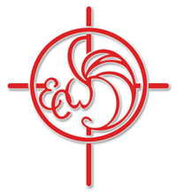

Episcopal Church Women

COME JOIN THE FUN! The ECW is having their annual fundraising gift basket raffle. Tickets will be sold Sunday before and after the 9am service. On June 14th the raffle will take place after the service. Tickets are $1 each or $5 for 6 tickets. Please join us for worship and the ECW raffle.

Thank you ECW

This will be the last Chronicle until September 2026
If you do have something for the Chronicle please have it to me by August 25, 2026. Thank you, Lesley
Daughters of the King

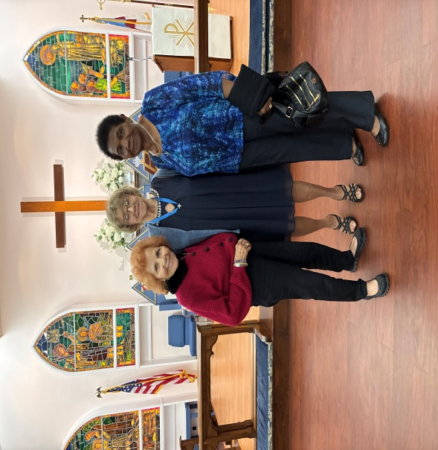
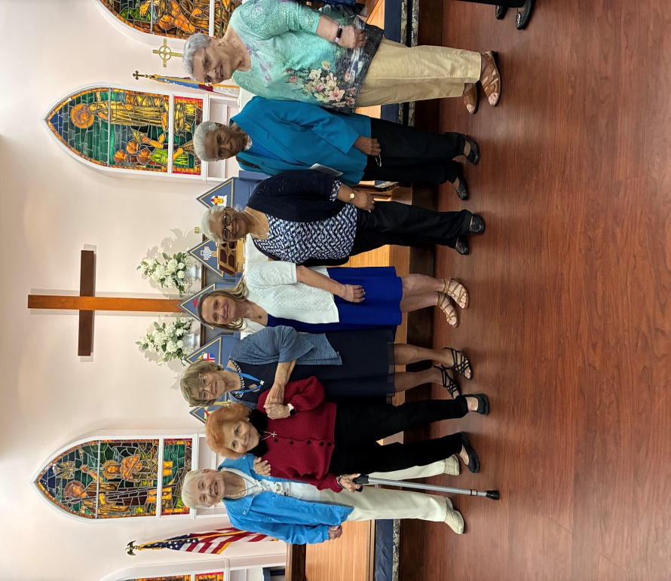

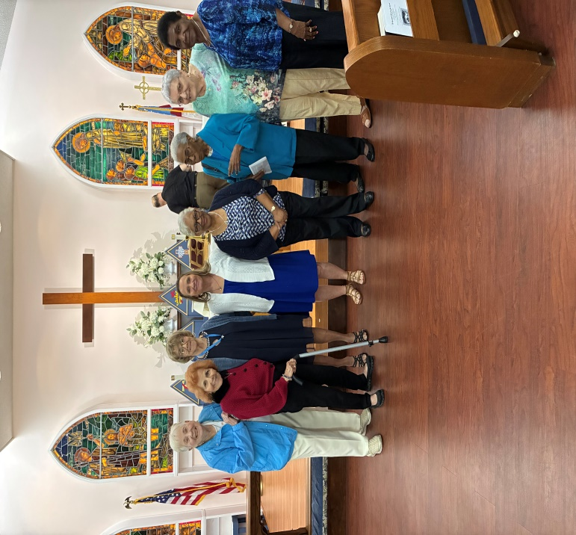
Marilyn French, Jane Tegeder, Kathy Consiglio, Trudy Knecht
Patricia Harrison, Sheila Ferguson, Virginia Collins, Rhoda Murdock
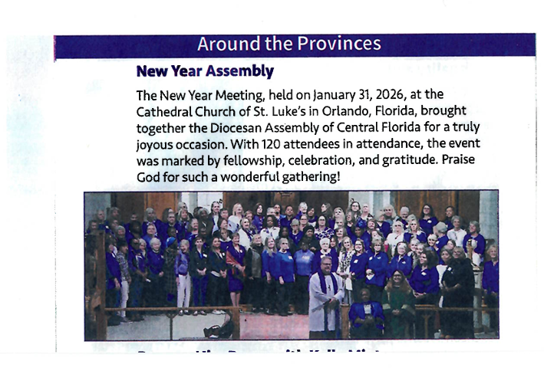
Find Trudy Knecht and Kathy Consiglio



The ECW will continue to support the schools: Sunrise Elementary, Horizon Academy and Marion Oaks Elementary. Supplies are needed for:
Teachers: Students:
Copy paper Crayons
Kleenex Glue sticks
Disinfection wipes Pencils
Pencil Sharpners Paper
Paper towels Rulers
Rulers Play Dough- one small can
Gallon & Pint Laundry Detergent
plastic size bags Bars of Soap
BackPacks
Need by end of September 2026



Coffee Hour

If you wish to help out will the coffee hour, call Lola Roseberry at (830) 889-2088
Where will be no coffee hour in June thru August. See you back in September

ECW Art Day
ECW meeting today included a workshop with Dori Sullivan creating personal greeting cards. Lots of laughs and brushes work!

From Left to right Lynn Paxson, Nancy Rodriquez, Kathy Consiglio, Susan McNeal, Marilyn French, Eneida Perez, Carol Robinson, Lola Roseberry.
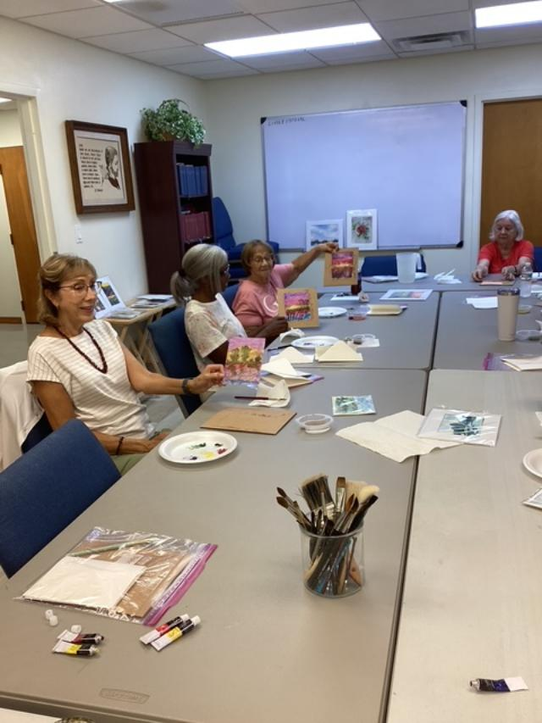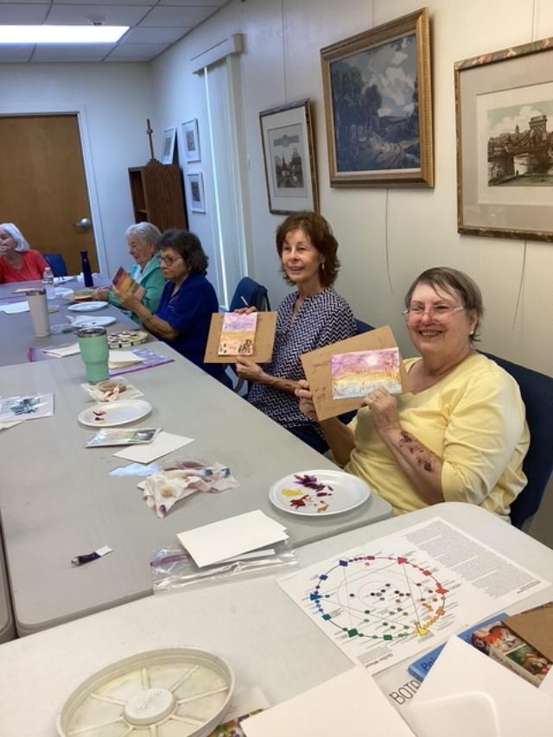
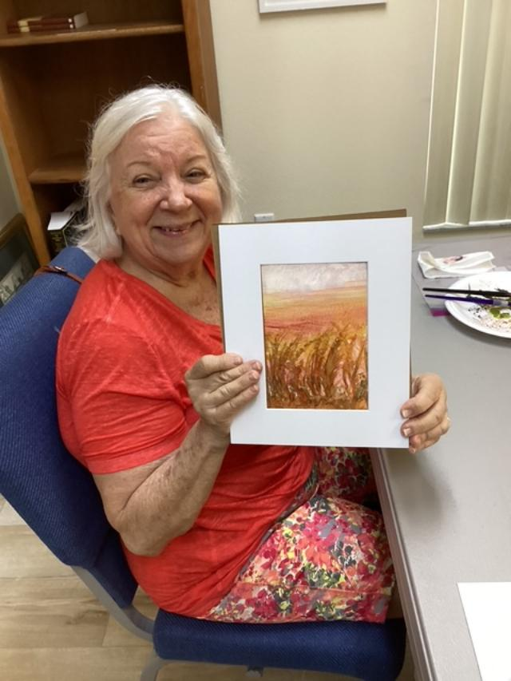

Milestones
If your birthday or anniversary is not listed or is incorrect please contact the office and let us know– we want to include you with our blessings and best wishes on your special day.
June BIRTHDAYS

Bigelow Robinson 06/01
Nancy Pickens 06/11
Eneida Perez 06/12
Patricia Harrison 06/16
Charlie Pratt 06/22
Casey Ying 06/26

July Birthdays

Nazimah Ying 07/12
Rhoda Murdock 07/21
Rev’d William Barrett 07/28
John McNeal 07/31

August Birthdays

Harold Hubbard 08/04
Virginia Collins 08/05
Bonnie Purnell 08/05
Jane Tegeder 08/05
John Menning 08/07
Rodger Spanjer 08/07
Dick Purnell 08/10
Chuck Birmes 08/11
Don Daniels 08/12
Stella Bender 08/18
Art McNeal 08/18
Claudette Burrows 08/24
Carol Molloy 08/24
Shirley Peloquin 08/27
Paul McGuckin 08/28

June Anniversaries

John & Linda Menning 06/19

July Anniversaries

Russell & Shirley Peloquin 07/18

August Anniversaries

Robert & Nancy Comeriato 08/12
Gordon & Elizabeth Herrick 08/21
Rodger & Rachael Spanjer 08/27

The Church is in need of Acolytes, Altar Guild helpers and Ushers. If anyone would like to volunteer or be a substitute please give Liz Herrick a call for Acolyte at (352) 291-4878 or e-mail her, For Altar Guild, please call Kathy Consiglio at (352) 465-7272 or e-mail her at ktgjjd6@gmail.com , Ushers call Lola Roseberry at (830)-889-2088 or e-mail her at texpepper@lcloud.com

Upcoming Events

June 3, 2026 - 9:00am to Noon is our Food Pantry

June 6, 2026 – Daughters of the King (DOK) Meeting at 10:30am

June 9, 2026 – Vestry Meeting at 5:00pm

June 13, 2026 – IHOP Breakfast Fellowship at 9:00am
June 13, 2026 – Altar Guild Meeting at 10:00am
June 20, 2026 – 8:00am Clean-up Day all are welcome to come out and help



The Advent Chronicle
Episcopal Church of the Advent
11251 SW Highway 484
Dunnellon FL 34432-6413

