THE ADVENT CHRONICLE
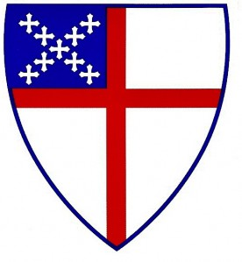

Our Purpose: Love God, Love One Another, Make Disciples
11251 SW Hwy 484
Dunnellon, FL 34432
(352) 465-7272

Office Hours
Mon., Wed., 8:30am – 12:30pm
Tuesday 8:30am – 4:00pm
Thurs. 8:00am - Noon
May 2026
episcopalchurchadvent@aol.com

A message from Fr. Barrett

The Lord be with you!

This month I am going to talk with you about stewardship. You may be tempted to stop reading once you get to the word “stewardship.” A couple of common reactions when the spiritual leader talks about stewardship are: “all he ever talks about is money” (you know that isn’t true) or “how dare he? I give all I can!” This is not an accusation. I discussed the topic of the tithe and stewardship already this year. I am taking a rare detour from my spiritual leader role to provide a frank discussion on numbers from a simple dollars and sense perspective.

We lost more than 50% of our weekly attendance post Covid. We are slowly growing again in membership and attendance. However, it is somewhat of a race now between achieving long term sustainability and running out of money. We have drained about 2/3 of our reserve fund since Covid ended. This is because we have run a double digit deficit ever since post Covid worship resumed. For the first three months of this year we are at a deficit of $$13,247.
CONTENTS

Message from Fr Barrett ∙ ∙ ∙ ∙ ∙1
Food Pantry Schedule ∙ ∙ ∙ ∙ ∙ ∙ ∙2
Episcopal Church Women∙ ∙ ∙ ∙ ∙2
Church, Gospel and Mission∙ ∙ ∙ 3
Milestones ∙ ∙ ∙ ∙ ∙ ∙ ∙ ∙ ∙ ∙ ∙ ∙ ∙ ∙ ∙4
Up Coming Events ∙ ∙ ∙ ∙ ∙ ∙ ∙ ∙ ∙ 4

Weekly Events
Sunday 9am Services
First Sunday of the month is a Healing Segment

Tuesday: 2ndTues. Vestry Meet at 5:00pm

Wednesday: First Wednesday of the Month is Food Pantry 9am - Noon
3rd ECW Meet at 10:00am

Friday: 12pm Stations of the Cross Only in Lent

Saturday:
1st Saturday of the Month DOK Meet at 10:30am

9:00am IHOP Fellowship on the 2nd Saturday of the month – All are welcome.
2nd Saturday Altar Guild Meet at 10:00am

Clean-up 8:00am on the 3rd Saturday of the month

In April the Vestry voted to draw out part of our CD of $112,281 by the last quarter of this year. At the current rate our remaining reserve fund will be depleted by the fall of this year. The only other liquid asset we will then have is our CD which we will begin drawing down.

I know that some members struggle with their income and inflation and are as generous as possible. I also thank you if you faithfully tithe. Therefore I am not asking you to increase your weekly or monthly pledge if you fall into either category. However, I know that some of our members are blessed with generous retirements and/or substantial retirement savings. Some of these folks have given us generous anonymous gifts in the past. They fall in the category of not millionaires but comfortably retired. Perhaps they are considering a bequest to the church. We need your help now.

I am issuing those folks an invitation for May 24 which is Pentecost Sunday. Let’s make this day an outpouring of the Spirit for Advent. I pledge to make a onetime gift of $500 over and above my pledge. I invite those who are able to join me. I estimate that this will raise about $14,000 which is enough to cover our current deficit and insure our reserve fund lasts until the end of the year and we don’t have to dip into our CD. Will you join me, if you can, in a Pentecost gift?

Peace Father Barrett

Food Pantry Schedule
May 6, 2026

Pickers: Gerry Baker/Pat Birmes

Runner: Lesley Ciullo

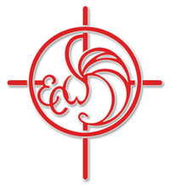

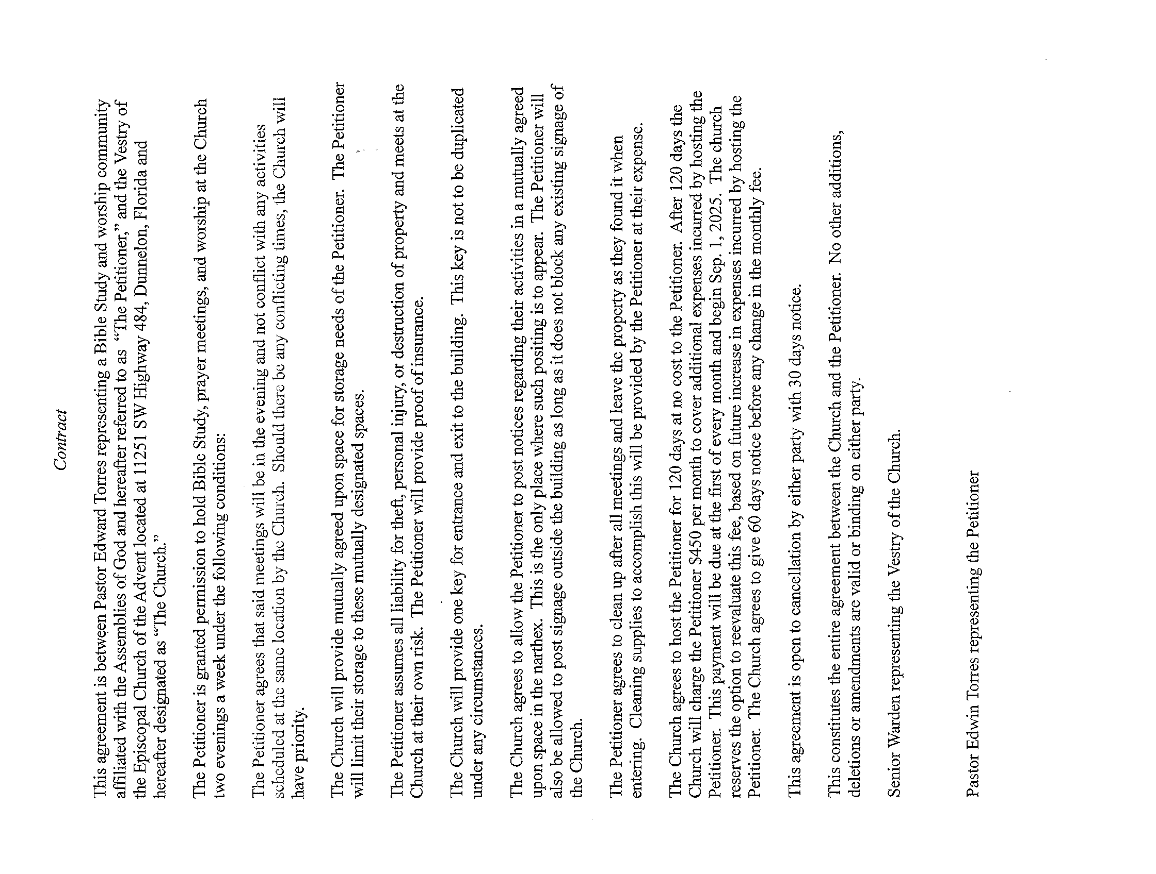

Episcopal Church Women

There is a ECW meeting on May 13th at 10:00am with Dori Sullivan teaching us painting skills.

Church, Gospel and Mission.

The 57th Central Florida Diocese Convention was held in Orlando in January, 2026. It had a wonderful theme, Church, Gospel and Mission. I was happy to be a part of the Clergy and Lay workers at the Convention where I learned more about our Diocese and the all-important outreach shared thru this Convention’s goals. Advent sent two delegates (myself and Shirley Peloquin) as well as our Clergy, Fr. Bill.
First, I begin with the Church. We are “grounded” within our individual churches. At Advent we are a praying community where our church family is always sharing prayers, teaching and caring for one another. Our missions spread our love thru our Food Pantry, Holiday Food Baskets and other community outreach events.
The Gospel is the basis for our spiritual growth. The more we read, talk, listen and recognize the Truth, the more our hearts are filled with the Holy Spirit. But we don’t stop there. Through the Diocese missions, the Word is spread around the world.
The Missions: There were four speakers at the Convention who talked about their outreach. The first was from Honduras – a long-time mission of the Diocese of Central Florida. They have built schools, homes and structures to serve the people of this Central American country.
The second speakers were a married couple whose ministry is in Southeast Asia. A portion of mixed countries and faiths that cover this most heavily populated area of our World. There is a blend of religions, but those missionaries work to bring the light of Jesus to new followers.
The third was a newer mission spearheaded by a retired military officer and Clergy. She has taken the path to serving veterans and those suffering from physical and mental challenges in our local communities.
Lastly was Fr. Stephen Dass and his wife who left Ocala several years ago to become missionaries to the homeless young people in Sao Paula Brazil. Fr. Dass has come to Advent in the past to tell us about their work. Their mission work is for the children and other lost individuals who have been living “on the streets” for generations. He and his wife Mary give the children one on one attention. They befriend them and help them learn about Jesus and the great commandment. Advent supports this mission with a pledged annual donation to their ministry. And I’m so happy that we do.
All the outreach by these Diocese missions – and others – are much needed but I feel close to the Sao Paulo ministry because it requires mostly prayer and focuses on the individual children of God, One at a time. You can find more information about all these missions thru the Diocese of Central Florida. Be assured that our prayers reach many beyond our small congregation.

Submitted by Dori Sullivan
Clerk of the Vestry

Milestones
If your birthday or anniversary is not listed or is incorrect please contact the office and let us know– we want to include you with our blessings and best wishes on your special day.
BIRTHDAYS

David Grigas 05/05
Jeanne Dooley 05/15
Rachael Spanjer 05/17
Shirley Thomas 05/19
Gordon Herrick 05/21
Ronald Purnell 05/22

Anniversaries

Bruce & Missy Monforte 05/02
Ronald & Lola Roseberry 05/17
Carlton & Avis Nettles 05/23

________________________________________________________________________

The Church is in need of Acolytes, Altar Guild helpers and Ushers. If anyone would like to volunteer or be a substitute please give Liz Herrick a call for Acolyte at (352) 291-4878 or e-mail her at tinlizziehr@yahoo.com, For Altar Guild, please call Kathy Consiglio at (352) 465-7272 or e-mail her at ktgjjd6@gmail.com, Bonnie & Dick Purnell for Ushers. Call Lola Roseberry at 830-889-2088 or Email: texpepper@lcloud.com

Upcoming Events

May 2, 2026 – Daughters of the King Meet at 10:30am

May 6, 2026 – Food Pantry 9am to Noon

May 9, 2026 –Bob Evans Breakfast Fellowship at 8:00am – All are Welcome

Altar Guild Meeting at 10:00am

May 12, 2026 – Vestry at 5:00pm

May 13, 2026 – Episcopal Church Women Meet at 10:00am

May 16, 2026 - Clean-up Day at the Advent at 8:00am

May 20, 2026 – Episcopal Church Women (ECW)

Corrections

If you see that an error was made, please call the office at (352) 465-7272 so that I have the right info.
Thank you, Lesley Ciullo
_____________________________________________________________________

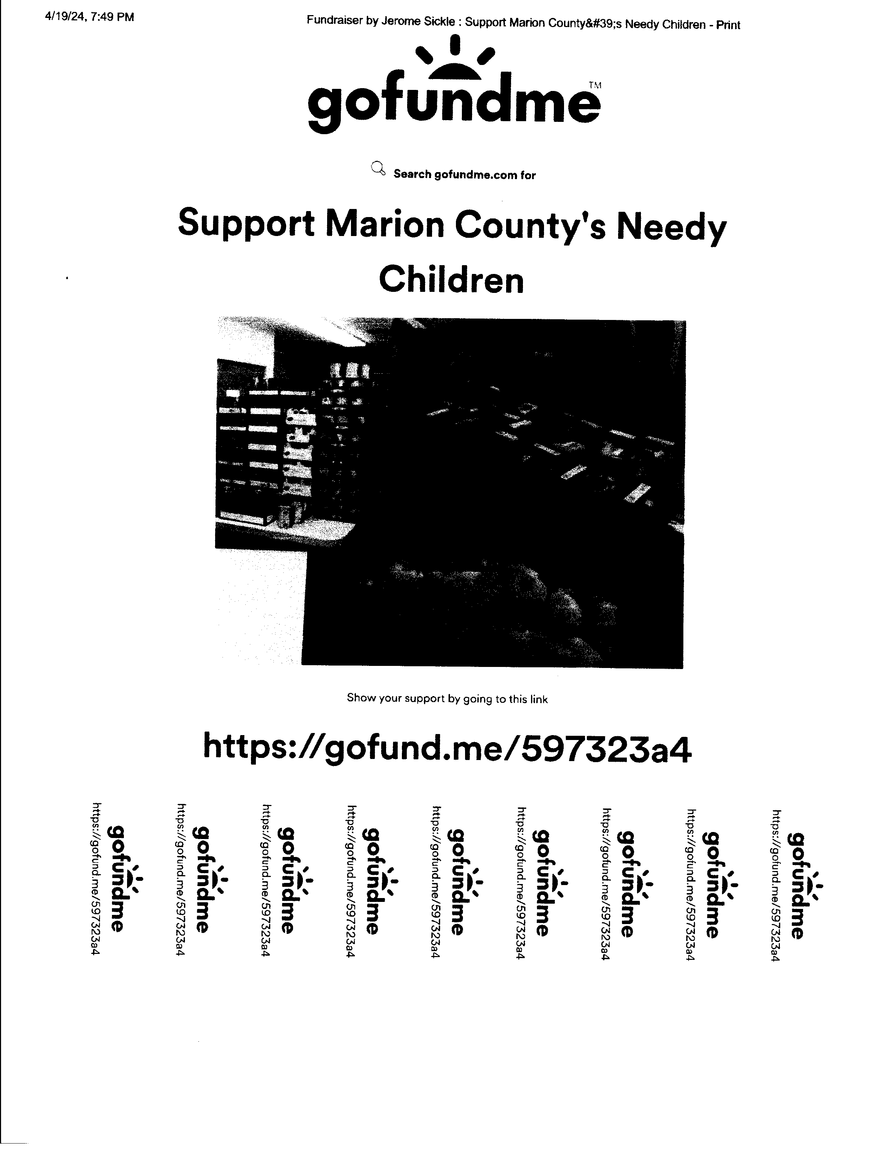


The Advent Chronicle
Episcopal Church of the Advent
11251 SW Highway 484
Dunnellon FL 34432-6413

