THE ADVENT CHRONICLE

Our Purpose: Love God, Love One Another, Make Disciples
Office Hours
Mon., Wed 8:30am – 12:30pm
Tuesday 8:30am – 4:00pm
Thursday 8:00am – 12:00pm
11251 SW Hwy 484
Dunnellon, FL 34432
(352) 465-7272

November 2025
episcopalchurchadvent@aol.com

CONTENTS

Message from Fr Barrett ∙ ∙ ∙ ∙ ∙ ∙ ∙ ∙ 1 Episcopal Church Women∙ ∙ ∙ ∙ ∙ ∙ ∙ ∙ 2
Pictures of Bishop Visit∙ ∙ ∙ ∙ ∙ ∙ ∙ ∙ ∙ ∙ 2 School Thank You Letters∙ ∙ ∙ ∙ ∙ ∙ ∙ ∙ 5
Food Pantry Schedule∙ ∙ ∙ ∙ ∙ ∙ ∙ ∙ ∙ ∙ ∙7
Volunteer’s Thank You ∙ ∙ ∙ ∙ ∙ ∙ ∙ ∙ ∙ ∙7
Attitude ∙ ∙ ∙ ∙ ∙ ∙ ∙ ∙ ∙ ∙ ∙ ∙ ∙ ∙ ∙ ∙ ∙ ∙ ∙ ∙ 8
Milestones ∙ ∙ ∙ ∙ ∙ ∙ ∙ ∙ ∙ ∙ ∙ ∙ ∙ ∙ ∙ ∙ ∙ ∙ 9
Up Coming Events ∙ ∙ ∙ ∙ ∙ ∙ ∙ ∙ ∙ ∙ ∙ ∙ ∙10

Weekly Events

Sunday: Mass is at 9:00am

Healing Service is the first Sunday of the month

Tuesday: 2nd Tues. Vestry Meet at 5:30pm
Wednesday: 1st Wed. of the month is Advents Food Pantry 9 to Noon
Every Wednesday - Choir Practice at 3:45pm.
3rd Wed. (ECW) Episcopal Church Women Meeting at 10:00am
Saturday:
1st Saturday of the Month DOK Meet at 10:30am.
2ndSaturday at 9:00am Bob Evans Breakfast Fellowship – All are welcome.
Altar Guild at 10:00am
3rd Saturday at 8:00am is Clean-up Day

A message from Fr. Barrett

The Lord be with you!

We will observe Advent with midweek worship beginning November 30. All worship will begin at 4:30pm. There will be NO meal preceding the worship. Out theme is “God with Us.” The schedule is:

Dec. 3 Our Potter

Dec. 10 Our Shepherd

Dec. 17 Our Living Branch

The Christmas schedule will be:

Dec. 24th Candlelight worship at 7:00 pm

Christmas Day Rite I 9:00am

Father Barrett

1

 Episcopal Church Woman

November tells us that Christmas is not far away. It also means it is time for the Salvation Army angel tree. The tags will be coming this month and the deadline December 1. This year we are requesting 40 children. The ages will range from very young to 11 or 12 if I remember correctly. Please help to give these children. A merry Christmas
Just a note the Altar Guild meets on the Second Saturday of the month at 10:00am and
ECW meets on the Third Wednesday of the month at 10:00am

Here are some picture from the Bishop’s Visit
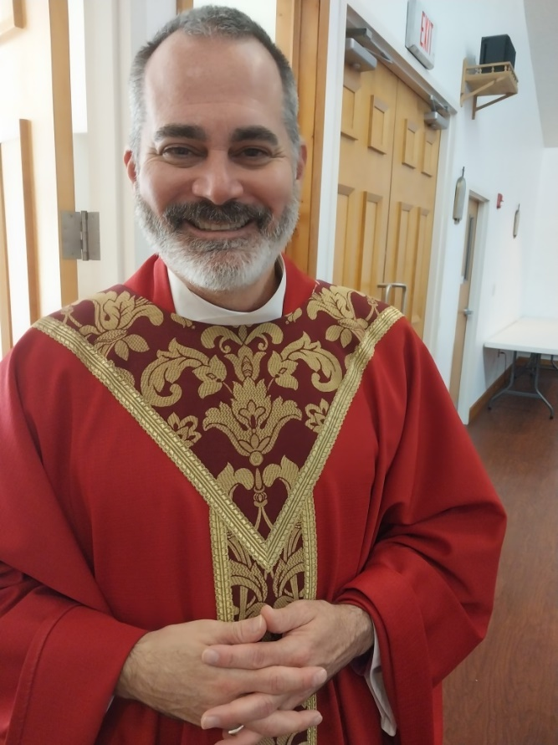
The Rt. Rev. Dr. Justin S. Holcomb
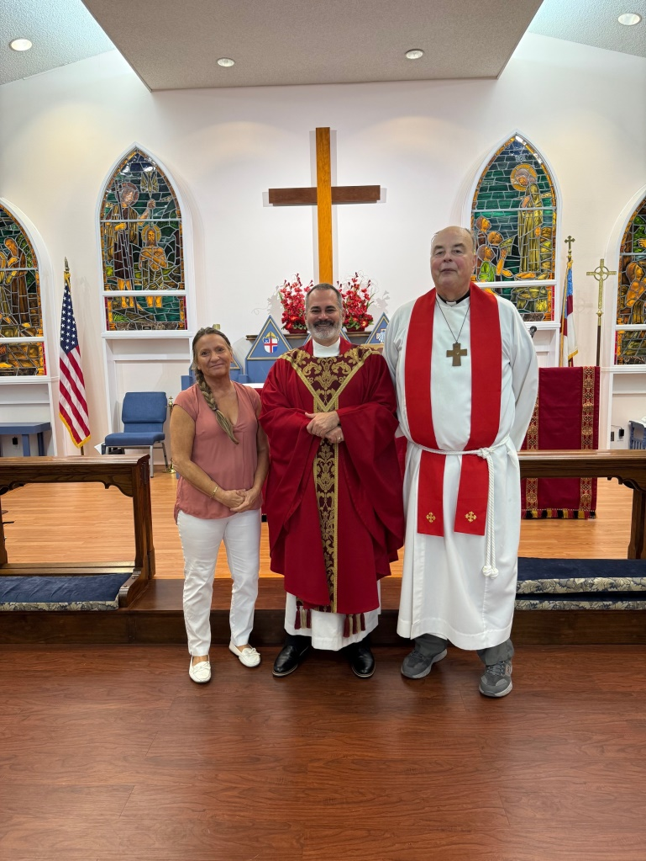
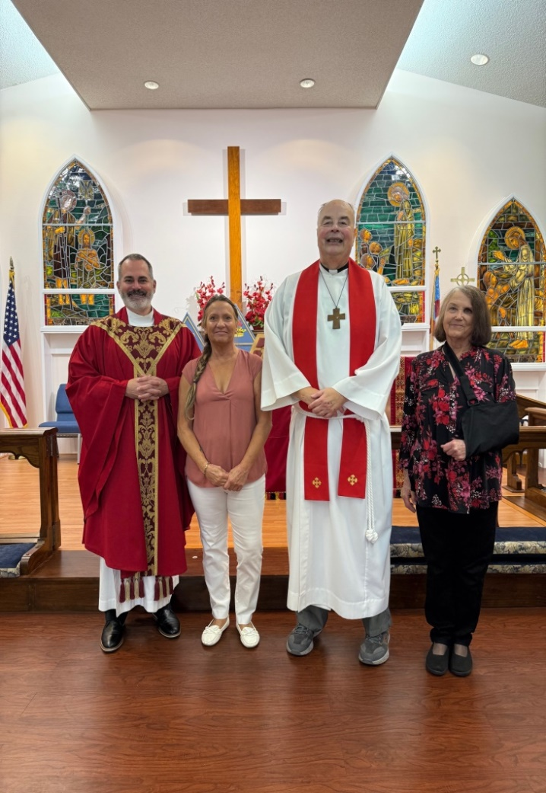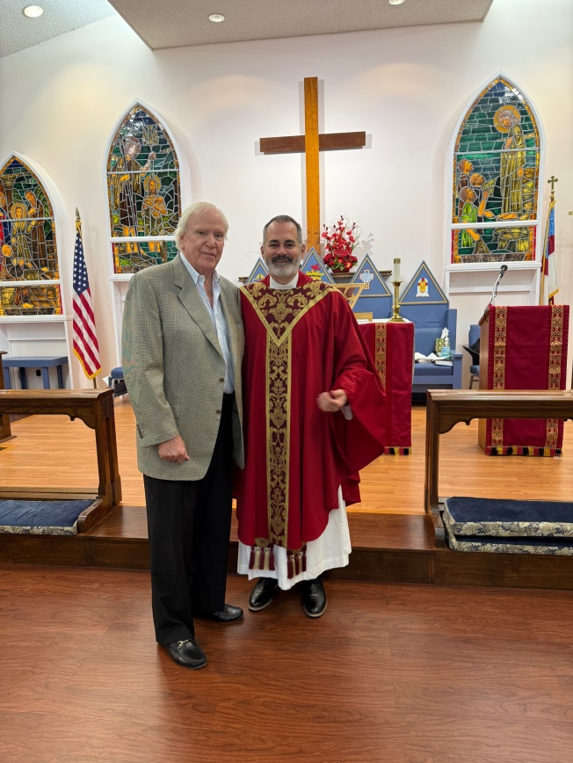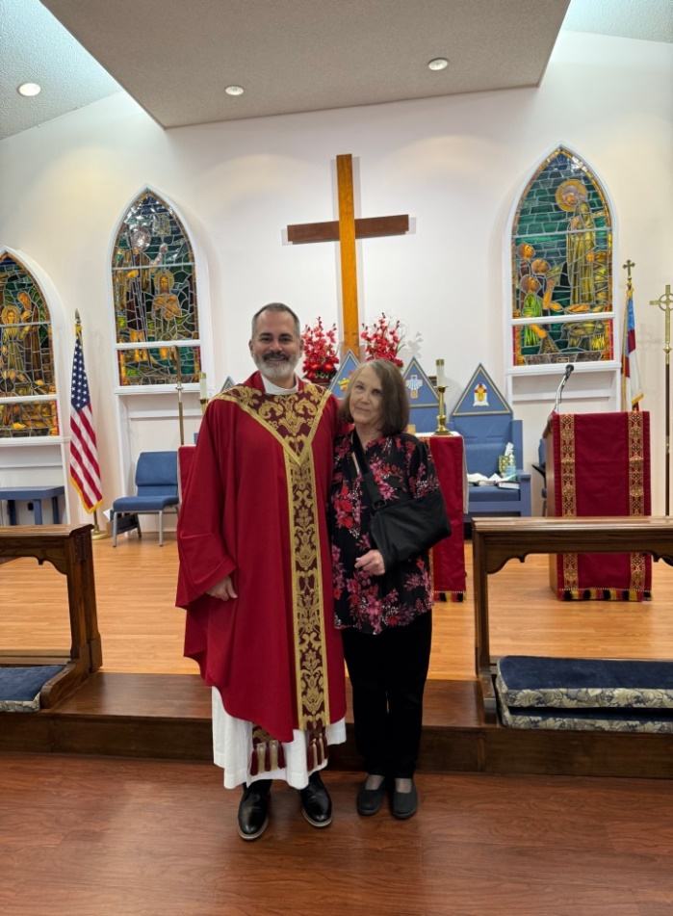
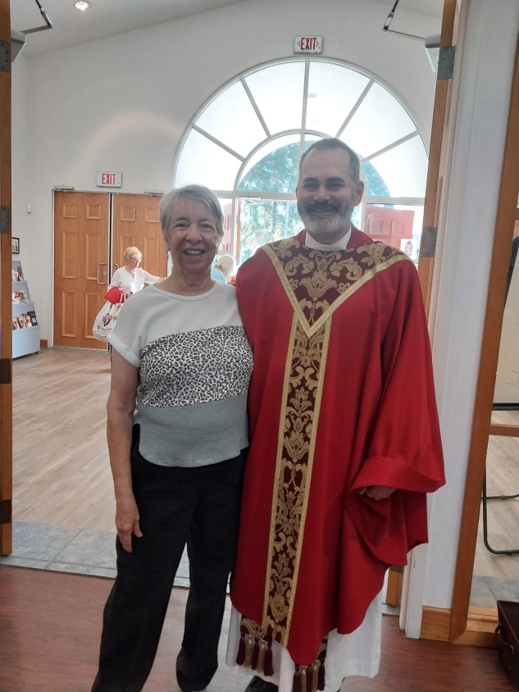
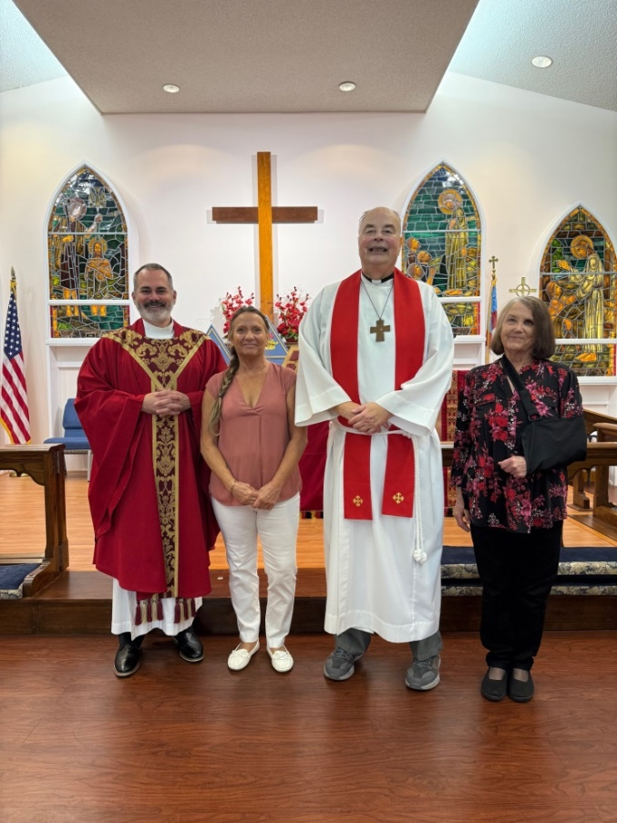
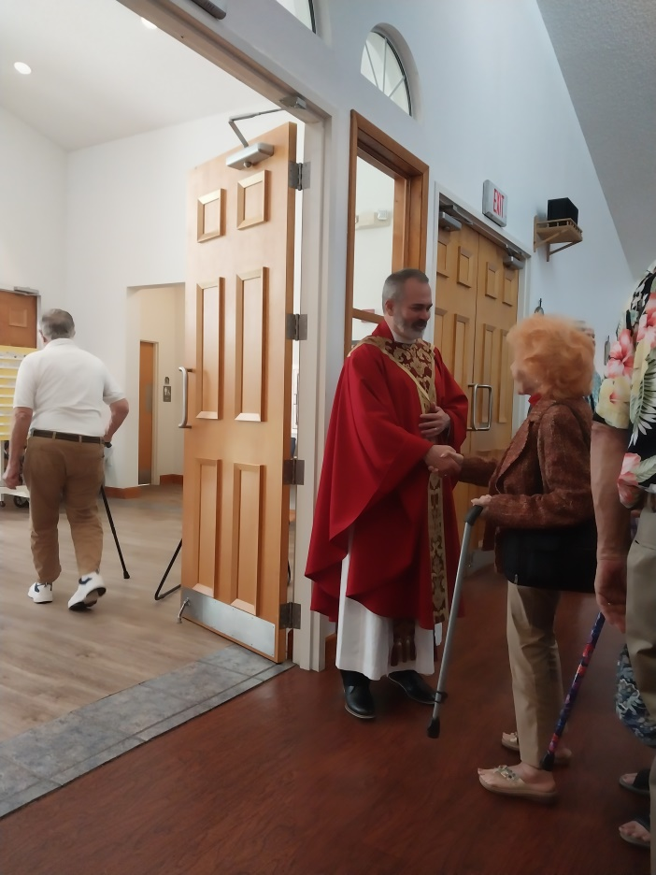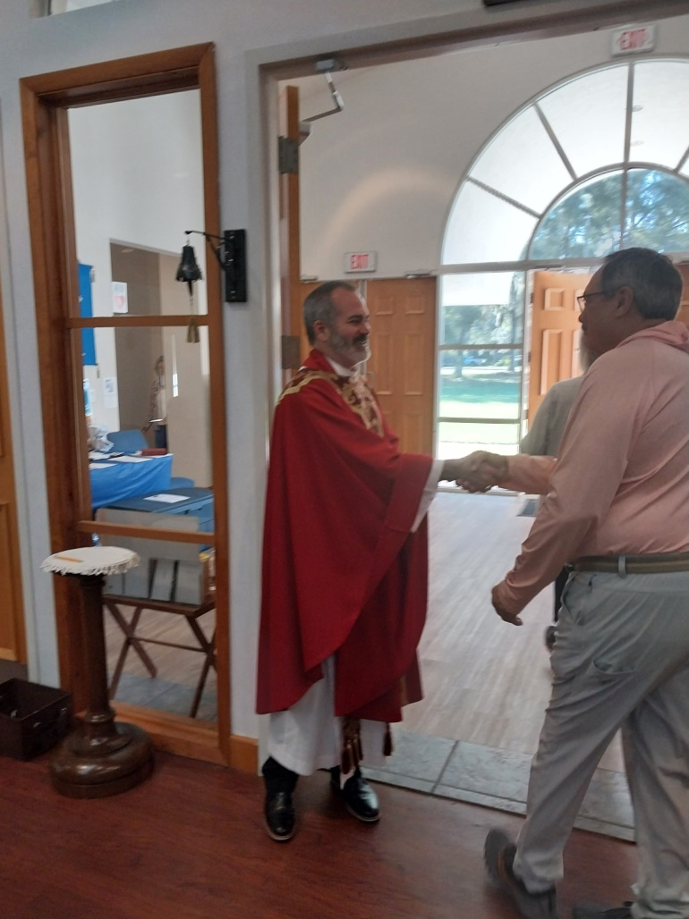


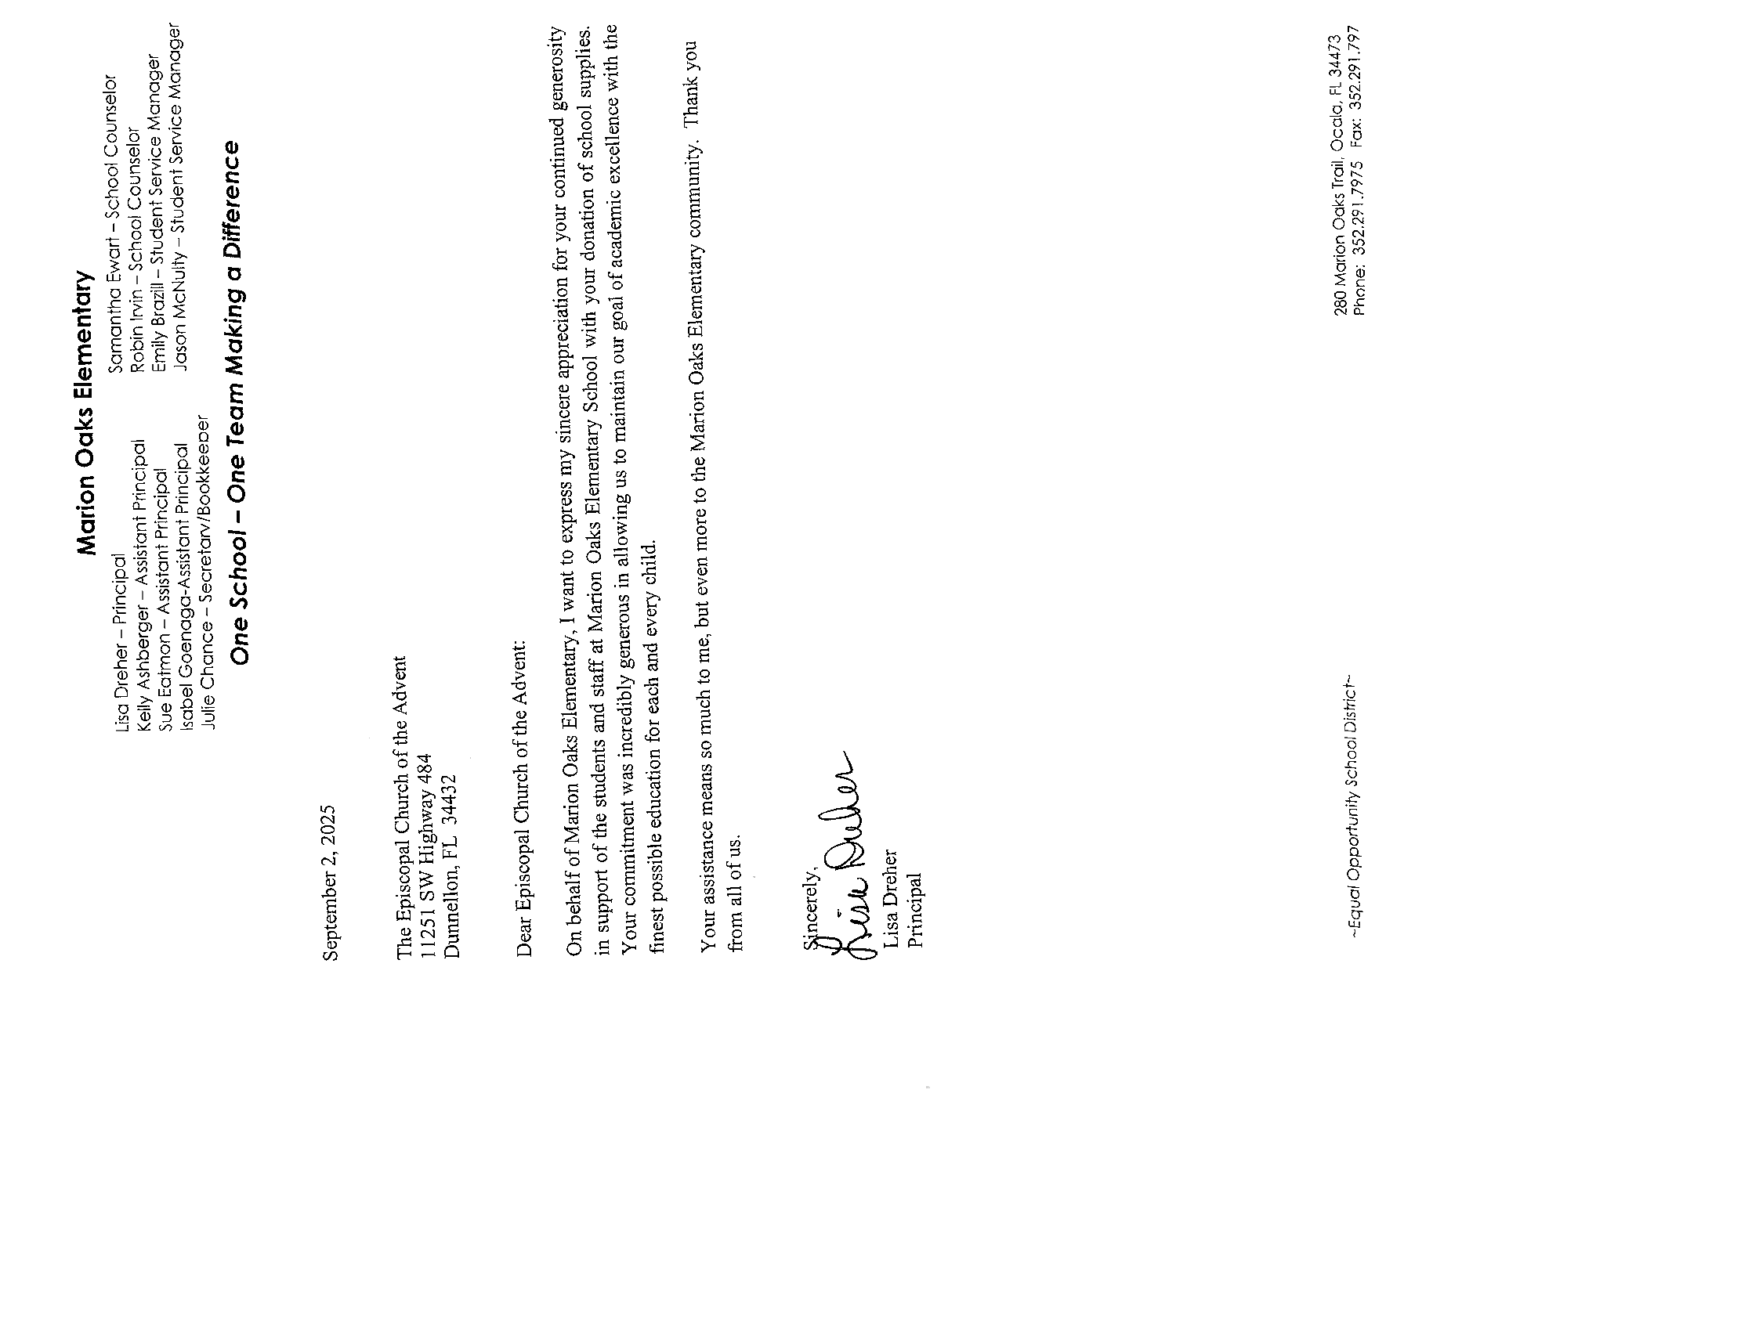
Here are Thank you Letter’s from Schools


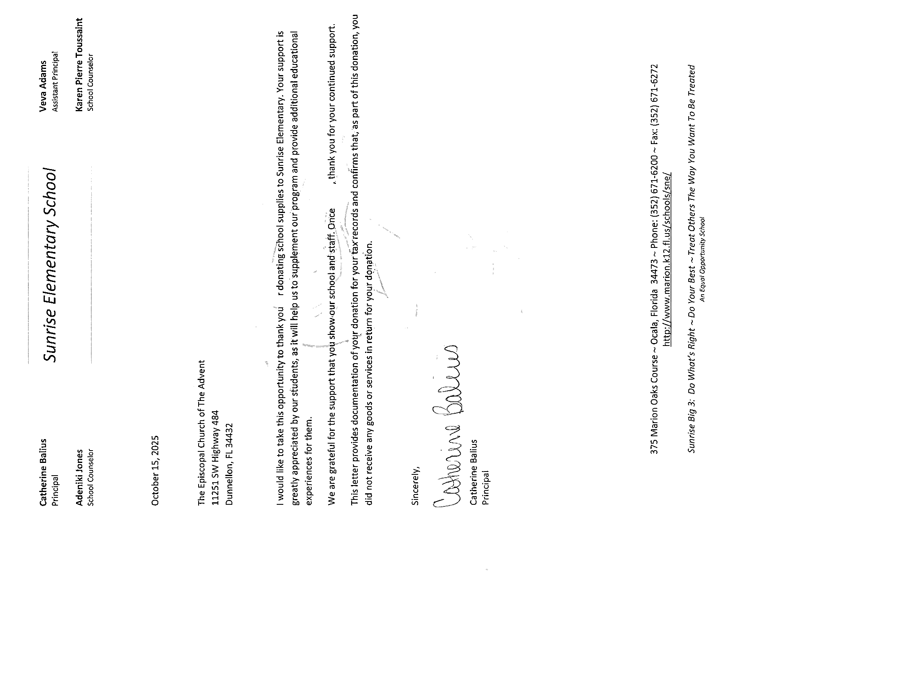


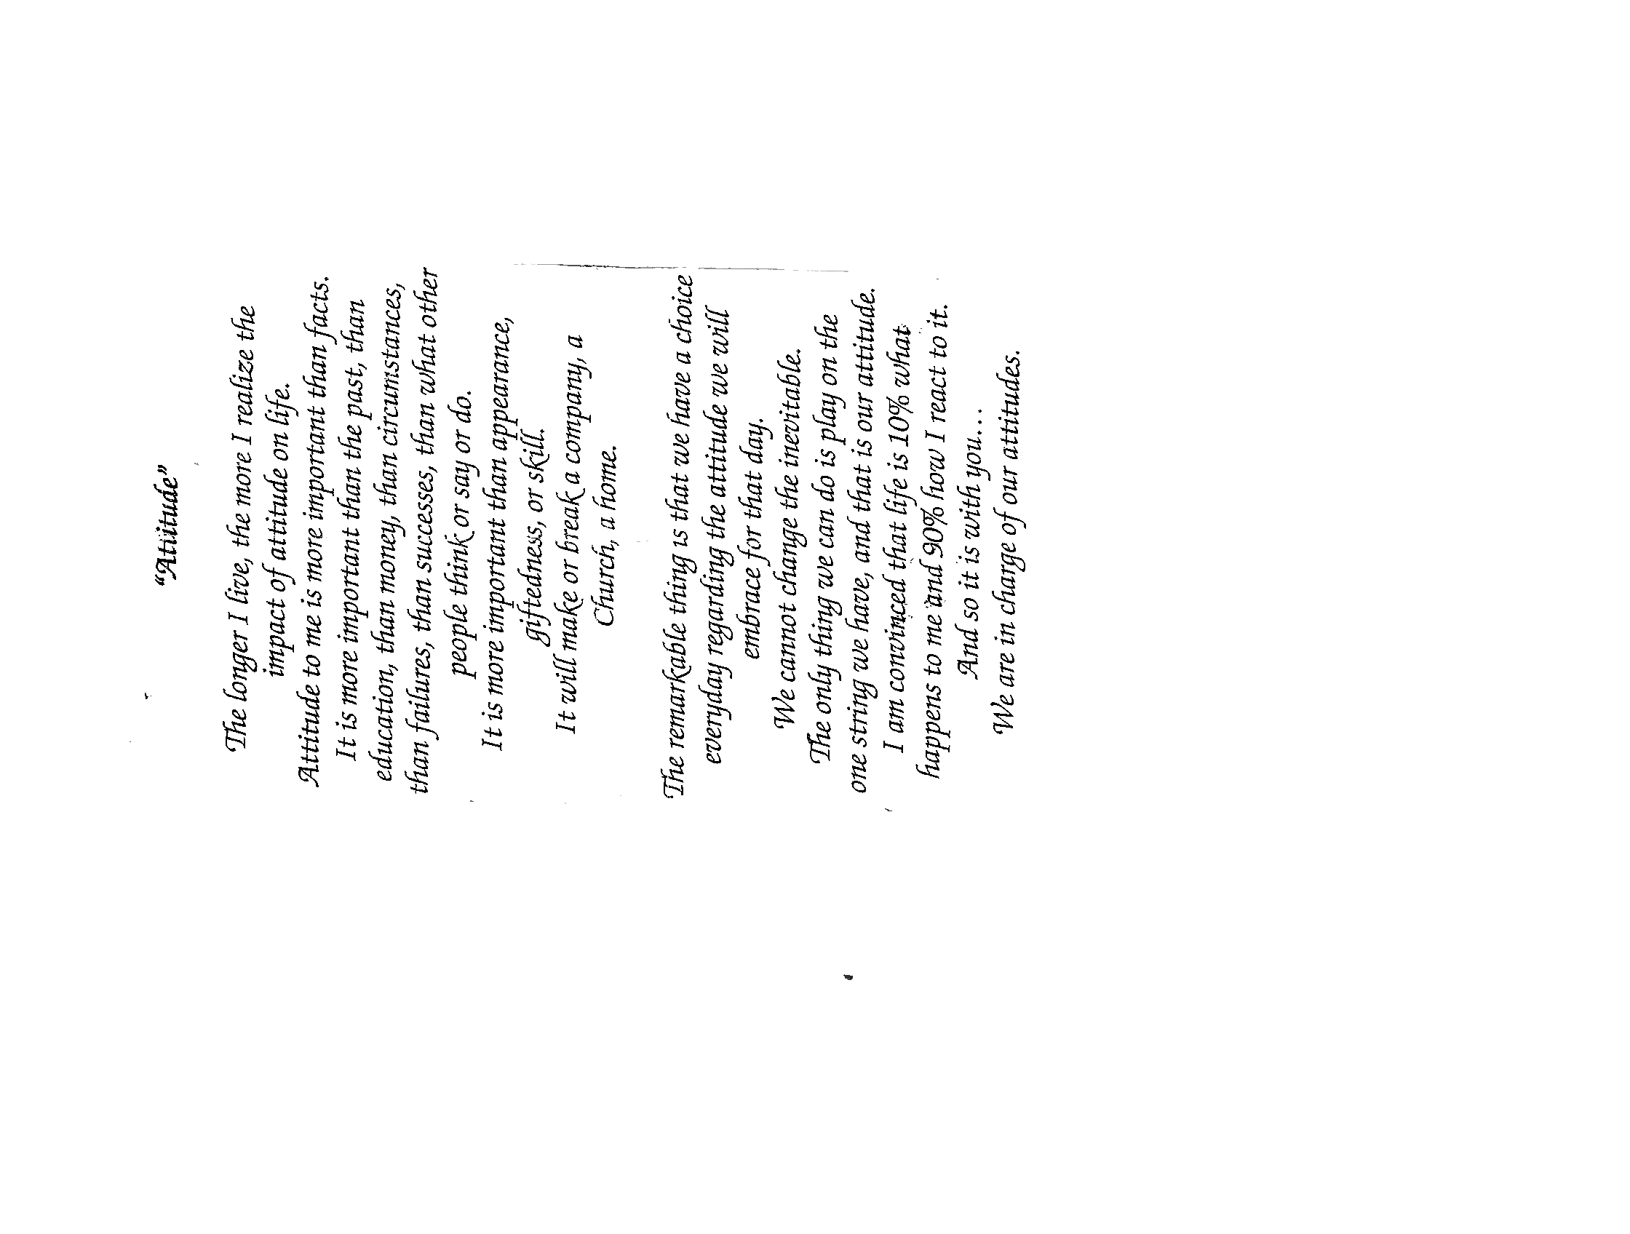
F0OD PANTRY NOVEMBER 5^{st,} 2025

Pickers: Don Daniels

Floater/Runner: Lesley Ciullo

﻿Dear Advent Friends,
> We thank each of you that volunteered for our September 27th Pet Blessing. A total of 52 pets were blessed by Fr. Bill that day. After the blessing folks could proceed to a game area with prizes for winners and snacks and bottled water were also offered. Our 23 volunteers were instrumental in our success that day and we could not have done it without you!! Again, we thank you all!
> Cindy and Carol
Here is a picture of all the volunteers

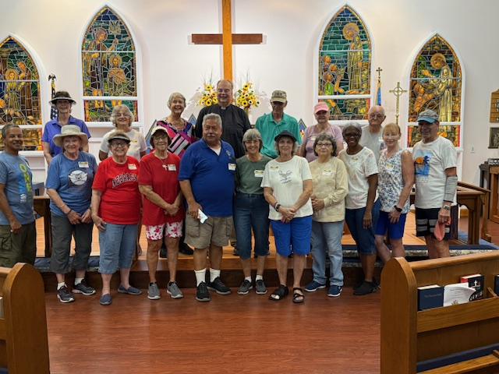

Missing from the picture is Cindy Spinning, Bigelow Robinson, Nancy McGuckin, Liz Herrick and Lola Roseberry

Milestones
If your birthday or anniversary is not listed or is incorrect please contact the office and let us know– we want to include you with our blessings and best wishes on your special day.

BIRTHDAYS

Diane Hutchinson 11/01
Avis Nettles 11/02
Wayne Baker 11/05
Irma McNeal 11/05
Carolyn Edonick 11/08
Charlene Gonzalez 11/09
Ashley Gonzalez 11/12
Daniel Wilson 11/18
Trudy Wells-Knecht 11/26
Bruce Monforte 11/27

ANNIVERSARIES

Wayne & Geraldine Baker 11/06
Peter & Carol Molloy 11/17
Bill & Linda Kenefick 11/18
Fr. Bill & Gaye Barrett 11/21

________________________________________________________________________

Psalms 121 Prayer Warrior’s – Fr. Bill Barrett – (352) 419-5242 or email him at pastorbill96@hotmail.com

The Church is in need of Acolytes, Altar Guild helpers and Ushers. If anyone would like to volunteer or be a substitute please give Liz Herrick a call for Acolyte at (352) 291-4878 or e-mail her at tinlizziehr@yahoo.com, For Altar Guild, please call Kathy Consiglio at (352) 414-4994 or e-mail her at ktgjjd6@gmail.com, Dick & Bonnie Purnell for Ushers. Call Bonnie at (386) 559-2491 or email: Purnell.bonnie@gmail.com. Dick at (727) 992-2397 or email: Purnell.rt@gmail.com

Upcoming Events

DO NOT FORGET TO SET YOUR CLOCKS BACK ON Saturday, November 1st

November 1st: Daughter of the King Meeting at 10:30am

November 4th, 11th, 18th & 25th Book Study at 1:00pm – Jesus was an Episcopalian (and you can be one too!) By Chris Yaw

November 5st: Food Pantry at the Advent 9:00am to Noon

November 5th, 12th, 19th & 24th Spanish Bible Study at 7:00pm

November 5th, 12th, 19th,26th: Choir Practice at 3:45pm

November 8th: Altar Guild Meeting at 10:00am

November 8th: Bob Evans Breakfast Fellowship at 9:00am

November 11th: Vestry Meet at 5:00pm all are welcome

November 15th: Clean-up Day at 8:00am – All are welcome to help out

November 19th: Episcopal Church Women at 10:00am

December 6th New Members Luncheon at 1:00pm

Corrections

If you see that an error was made, please let me know, so that I have the right info.
Thank you, Lesley Ciullo



The Advent Chronicle
Episcopal Church of the Advent
11251 SW Highway 484
Dunnellon FL 34432-6413

