THE ADVENT CHRONICLE

Our Purpose: Love God, Love One Another, Make Disciples
11251 SW Hwy 484
Dunnellon, FL 34432
(352) 465-7272

Office Hours
Mon., Wed., Thurs., 8:30am – 12:30pm
Tuesday 8:30am – 4:00pm
September 2025
episcopalchurchadvent@aol.com

CONTENTS

Message from Fr Barrett ∙ ∙ ∙ ∙ ∙ ∙1
ECW Episcopal Church Women ∙ ∙2
ECW Basket Winner ∙ ∙ ∙ ∙ ∙ ∙ ∙ ∙ ∙ 3
ECW 2025-2026 Schedule∙ ∙ ∙ ∙ ∙ 4
Food Pantry Schedule∙ ∙ ∙ ∙ ∙ ∙ ∙ ∙ 5
Say “Yes”∙ ∙ ∙ ∙ ∙ ∙ ∙ ∙∙ ∙ ∙ ∙ ∙ ∙ ∙ ∙ ∙5
Silent Auction∙ ∙ ∙ ∙ ∙ ∙ ∙ ∙ ∙ ∙ ∙ ∙ ∙ 6
Pet Blessing∙ ∙ ∙ ∙ ∙ ∙ ∙ ∙ ∙ ∙ ∙ ∙ ∙ ∙ ∙7
Information for Seniors∙ ∙ ∙ ∙ ∙ ∙ ∙8
Milestones ∙ ∙ ∙ ∙ ∙ ∙ ∙ ∙ ∙ ∙ ∙ ∙ ∙ ∙ ∙ 9
Up Coming Events∙ ∙ ∙ ∙ ∙ ∙ ∙ ∙ ∙ ∙ 9

Weekly Events

Sunday: Services at 9 am
7:00pm Spanish Worship

Tuesday: Second Tuesday of the Month: Vestry Meet at 5:30pm

Wednesday: First Wednesday of the Month is the Food Pantry 9am – Noon. Third Wednesday of the Month is Episcopal Church Women at 10:00am
Every Wednesday Choir Practice at 3:30pm

Thursday: Spanish Bible Study at 1:00pm

First Saturday of the month: Daughters of the King Meet at 10:30am. Second Saturday of the month is Bob Evans Breakfast at 9:00am. The Third Saturday of the month is Clean-up Day at the Advent at 8:00am

A message from Fr. Barrett
The Lord is risen!

It is September, back to school month. This is also the month when churches tend to awake from summer hibernation. Many congregations kick this off with an event called “Rally Day.” The monthly newsletter resumes. If Christian ed. classes such as Sunday school, were suspended for the summer, they resume. Attendance tends to increase as vacations end and snow birds return home. This is all well and good. There is One who does not observe this cycle-God. The apostle Peter exalts us to “always be prepared to give an answer to everyone who asks you to give the reason for the hope that you have.” (1 Peter 3:15.

This Sunday I invite you to look carefully at your bulletin while waiting for the Mass to begin. On the back you will find a list of our ministries as well as the names of the members who serve on the Vestry. You may have glanced at this over the years or never noticed it. You may consider it as unnecessary information or of passing interest with no relevance to the Mass. This Sunday I ask you to consider it an invitation. The apostle James exhorts all of us to be not just “hearers of the Word, but doers of the Word.” I don’t think this is simply a call to personal morality. I think it is a call to participate in the life of the congregation. Christianity is lived out in the context of community. We are a family of believers called together by one Lord.

Take a moment to consider your gifts. God makes two promises through Christ. The first is that every Christian is given one, and usually more than one, gift from the Holy Spirit in our baptism. The second is that God will never call us to a ministry without giving us the tools to accomplish that ministry.

Every Sunday I rejoice to see our members taking time to greet each other in the sharing of the peace. It is a wonderful sign of our solidarity in Christ. Another sign is using our gifts for the mutual building up of the body of Christ. The apostle Paul wrote this to the Ephesians: It was he who gave some to be apostles, some to be prophets, some to be evangelists, and some to be pastors and teachers, to prepare God’s people for works of service, so that the body of Crist may be built up until we all reach unity in the faith and n the knowledge of the son of God and become manure, attaining to the whole measure of the fullness of Christ. (Ep. 4:11-13).
I urge you to reverse the message of the prosperity preachers of the gospel. “Ask not what Jesus can do for you, ask what you can do for Jesus and his Church.”

Father Barrett



Episcopal Church Women


The ECW will continue to support the schools: Sunrise Elementary, Horizon Academy and Marion Oaks Elementary. Supplies are needed for:
Teachers: Students:
Copy paper Crayons
Kleenex Glue sticks
Disinfection wipes Pencils
Pencil Sharpners Paper
Paper towels Rulers
Rulers Play Dough- one small can
Gallon & Pint Laundry Detergent
plastic size bags Bars of Soap
BackPacks

Need by end of September 2025

ECW’s Basket Winners
(Pictures by Nancy McGuckin)

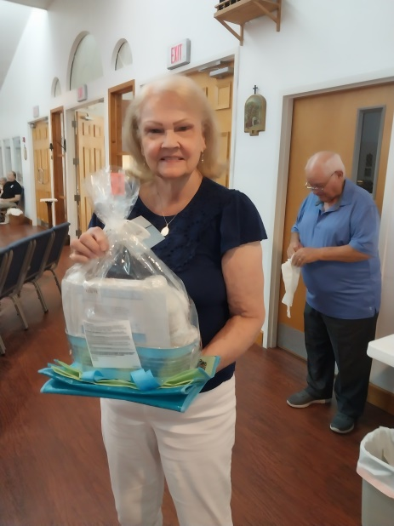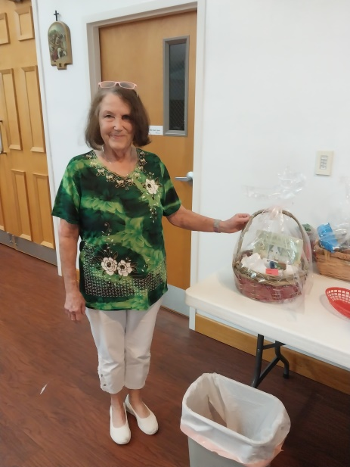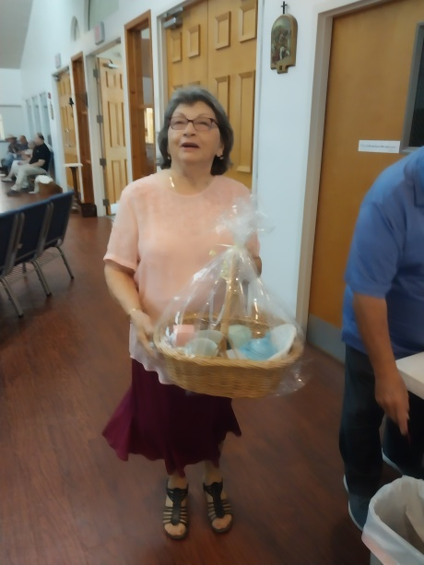
Linda Menning Cindy Spinning Eneida Perez
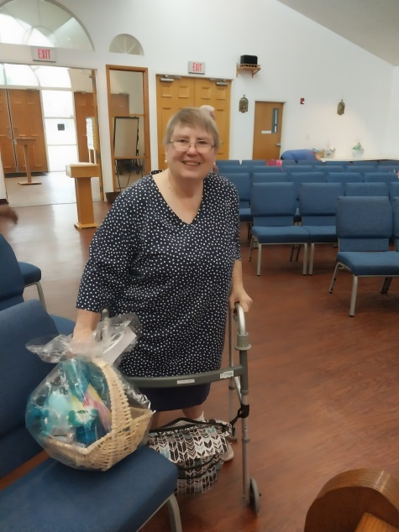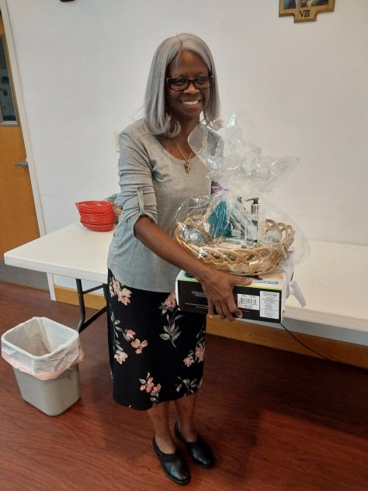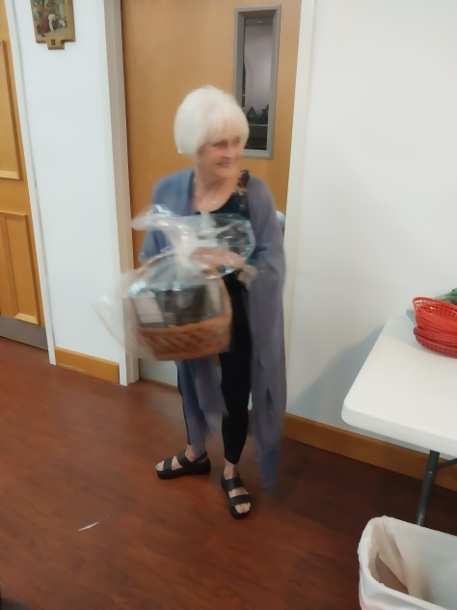
Lola Roseberry Nancy Rodriquez Dorothy Dexter

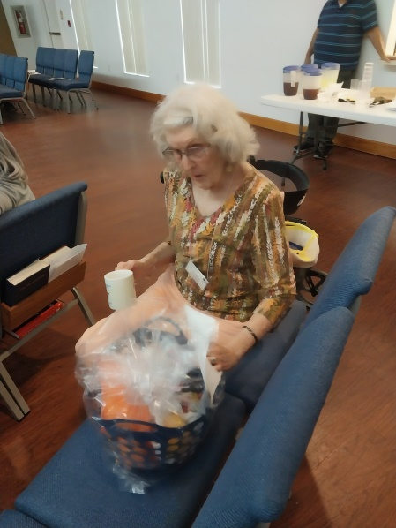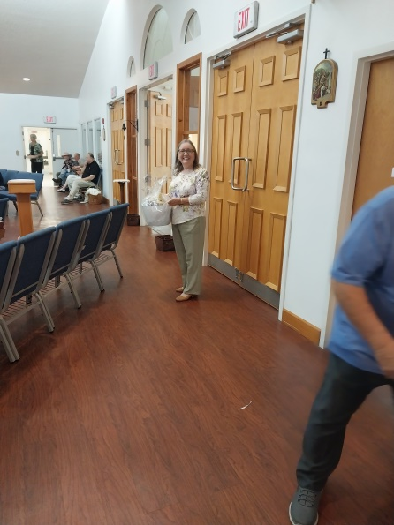

Jeanne Dooley Shirley Newhart

Others winners, not in the picture were Nazimah Ying, Missy Monforte, Gordon & Liz Herrick, Paul McGuckin, Janet friend of Cindy Spinning

ECW 2025-2026 MEETING SCHEDULE

The ECW is planning another fun and interesting year in our mission to support the Church of the Advent. Please make note of the meeting dates below and plan to become an active part of the ECW.

All women of Church of the Advent are automatically members of ECW.

Meetings are scheduled for the third Wednesday of the month at 10:00 AM in the church classroom. Dates, time and location may be changed to accommodate specific activities.

September 17
October 15
November 19
December 17

January 21
February 18
March 18
April 15
May 20

Questions? Please contact Liz Herrick.

Food Pantry Schedule for September 3, 2024

Picker: Charlie Pratt

Runner: Lesley Ciullo

Say “Yes” !
These days there doesn't seem to be enough time during our waking hours for all that we have to do. But I want to encourage you to think about doing something more. Advent is our church family for our members. We love one another and our Faith. We have made a commitment to attend services and join in some of our projects and mission work. But we recognize that there will come a time when we need you to say “yes” and step up to share your time and talent with Advent.
I’d like to invite you to think about your time and energies and perhaps consider “shadowing” some of our volunteers at the altar or within our various groups so you will feel prepared to step up when the call is made for volunteers. Find an area that interests you … singing in the choir or helping in the kitchen. Join up with the Daughters of the King and contribute your prayers for the needs of others. Start a new group – a few friendly lunch dates or craft hour once or twice a month or … well – what would you like to do?
The rewards are many. You’ll get to know more about those who sit next to you for an hour or so every week. You’ll be amazed and grateful to learn their story. We have so much in common. You’ll learn more about yourself as you pursue working together with other volunteers who have the same goals. You are an important part of obeying God’s commandment “Love God and Love Your Neighbor”.
Submitted by Dori Sullivan

A Silent Auction – September to October 1st!
Advent was given four unique works of art that are on display in the classroom from now until the first part of October. The donor has said whatever proceeds are made from the sale of these paintings will go directly to Church of the Advent. It was decided that a “Silent Auction” was a way of giving our parishioners the opportunity to bid on any piece that appeals to you. Bid sheets are posted on the bulletin board outside the classroom. When you decide, simply put your name, phone number and bid on the sheet … others may “outbid” you, but no worries, you can boost your bid … and so it goes. The last bid, at the close of the auction, is the winner. You will be notified if that winner is you! Payment by the winners are given directly to Advent.
The four pieces of artwork include one small scenic original framed oil painting, a large framed Country Road stitched piece and two framed, signed and numbered lithograph prints of a Hungarian Village with church or a cityscape of bridges. Come and take a look at the display next time you’re in church. Questions? Contact Dori Sullivan sullivandori128@gmail.


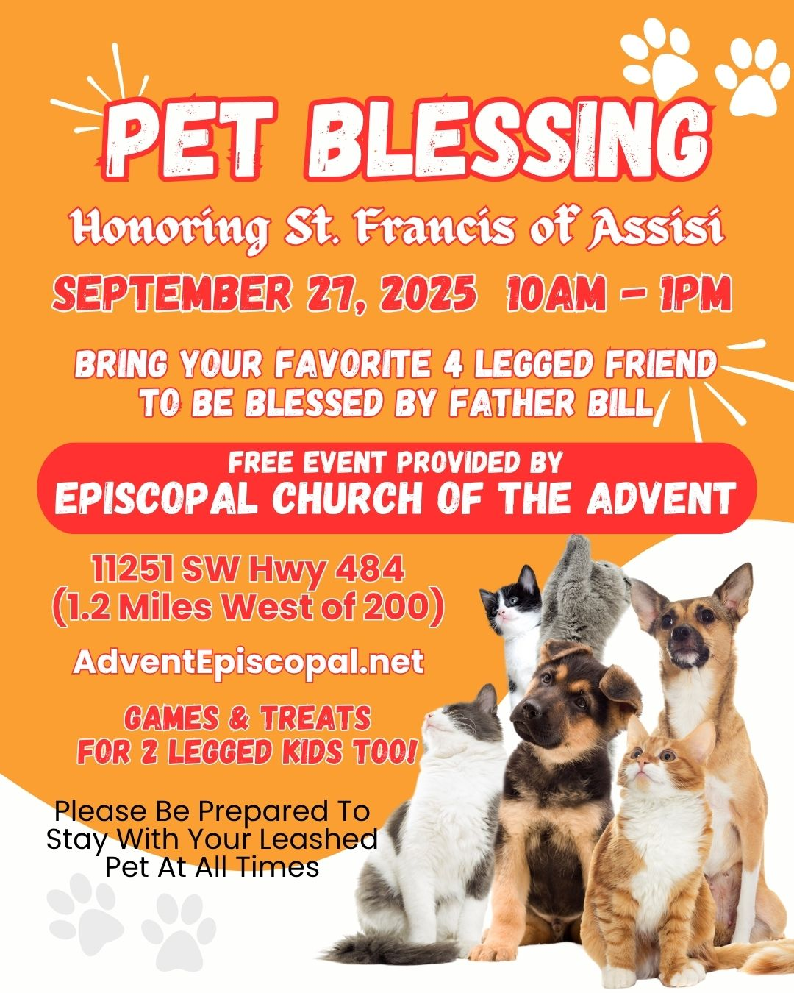
Information on independeant living and assisted Living facilities

BROOKDALE CANOPY OAKS
BACK GATE OF otow ON 80TH AVE. (ONLY ASSISTED LIVING AND MEMORY CARE) 9070 sw 80TH aVE, 352-861-4444
bRIDGEWATER pARE – independent LIVING AND ASSISTED LIVING
CONTACT – KIM MUSE DIRECTOR OF COMMUNITY RELATIONS 352-509-5202 OPT. 2 9174 sW 81 ST CT. OFF 80TH AVE. THREE FORM OU CHURCH IVE THERE.
CANTERFIELD OF OCALA – ASSISTED LIVING AND INDEPENDENT LIVING
9589 SW HIGHWAY 200 OCALA, FLORIDA 34481 352-877-7100
sTUDION APTS. START AT $4,200 PER MO. PLUS LEVEL OF CARE $500+
PLUS COMMUNITY ONE TIME FEE PLUS OTHER FESS, TV ETC.
tAYLOR WASSON, MARKETING DIRECTOR N
OCALA SENION LIVING – INDEPENDENT LIVING – ASSISTED LIVING
11311 SW 95TH CIRCLE OCALA, FLORIDA 34481 352-306-8601
AARON GARY, CDAL, CDP REGIONAL EX. DIRECTOR
PRIVIATE STUDIO START $4,050 PER MO. PLUS LEVEL OF CARE
BROOKDALE CHAMBREL PINECASTLE
1801 sE 24TH ROAD OCALA, FLORIDA INDEPENDENT LIVING, ASSISTED LIVING AND MEMORY CARE
ANY OF THESE SENIOR LIVING PLACES CAN BE FOUND ON-LINE FOR MORE INFORMATION OR CAN BE CONTACTED TO THAKE A TOUR. SOME WILL TAKE MEDICAID LIMINTED.
MARILYN FRENCH, 352-873-8358
SENIOR ADVOCATE

Milestones
If your birthday or anniversary is not listed or is incorrect please contact the office and let us know– we want to include you with our blessings and best wishes on your special day.
BIRTHDAYS

Yvonne Daniels 09/03
Brian Ying 09/07
Peter Molloy 09/12
Missy Monforte 09/16
Jane Falkner 09/17
Shirley Newhart 09/20

Anniversaries

Rupert & Yvonne Daniels 09/02
Dick & Bonnie Purnell 09/03
Joe & Eneida Perez 09/05
Roger & Diane Hutchinson 09/10

The Church is in need of Acolytes, Altar Guild helpers and Ushers. If anyone would like to volunteer or be a substitute please give Liz Herrick a call for Acolyte at (352) 291-4878 or e-mail her at tinlizziehr@yahoo.com, For Altar Guild, please call[ Kathy Consiglio at S(352) 414-4994 or e-mail[ her at ktgjjd6@gmail.com Bonnie & Dick Purnell for Ushers. Call Bonnie at (386) 559-2491 or e-mail: Purnell.bonnie@gmail.com Dick (727) 992-2397 or e-mail: Purnell.rt@gmail.com

Upcoming Events for 2025

Wednesday, September 3rd: Food Pantry at 9:00am to Noon

Saturday, September 6th: Daughters of the King Meet in the Sanctuary at 10:30am

Tuesday, September 9th: Prayer for Spanish speaking people – Pastor Maribel Torres – 10am to 12:00pm

Vestry Meet at 5:00pm

Saturday, September 14th: Bob Evans Breakfast Fellowship at 9:00am

Wednesday September 17th: Episcopal Church Women Meet at 10:00am

Saturday, September 20th: Clean- up Day at Advent – All are welcome


The Advent Chronicle
Episcopal Church of the Advent
11251 SW Highway 484
Dunnellon FL 34432-6413

