THE ADVENT CHRONICLE

Our Purpose: Love God, Love One Another, Make Disciples
Office Hours
Mon., Wed., 8:30am – 12:30pm
Tuesday 8:30am – 4:00pm
Thursday 8:00am – 12:00pm
11251 SW Hwy 484
Dunnellon, FL 34432
(352) 465-7272

October 2025
episcopalchurchadvent@aol.com

CONTENTS
Message from Fr Barrett ∙ ∙ ∙ ∙ ∙ ∙1
Episcopal Church Women∙ ∙ ∙ ∙ ∙ ∙2
Food Pantry Schedule∙ ∙ ∙ ∙ ∙ ∙ ∙ ∙ 4
Coffee Hour∙ ∙ ∙ ∙ ∙ ∙ ∙ ∙ ∙ ∙ ∙ ∙ ∙ ∙ ∙ 4
Milestones ∙ ∙ ∙ ∙ ∙ ∙ ∙ ∙ ∙ ∙ ∙ ∙ ∙ ∙ ∙ ∙5
Up Coming Events ∙ ∙ ∙ ∙ ∙ ∙ ∙ ∙ ∙ ∙ 6

Weekly Events

Sunday Mass at 9:00am

1st Sunday of the month is Healing Segment

2nd Tuesday of the month is Vestry Meet at 5:30pm

1st Wednesday of the Month is Food Pantry 9:00am to Noon
3rd Wednesday (ECW) Episcopal Church Women Meet at 10:00am
Every Wednesday at 3:45pm Choir Practice

First Saturday: at10:30am Daughters of the King Meet
Second Saturday: at 8:00am Bob Evans Breakfast Fellowship – All are Welcome
10:00am Altar Guild Meeting
Third Saturday: at 8:00am clean-up Day – All are welcome

A message from Fr. Barrett

The Lord is risen!

I have just finished a book entitled “Signs of Life” by Jay Sidebotham. This book was published by Forward Movement, a ministry of the Episcopal Church. He starts by quoting the research work of Cally Parkionson, a former member of mega church Willow Creek, and a church consultant with REVEAL In her work she identifies eight kinds of congregations which are:

VIBRANT-Faith among members is strong, mature, and growing. People love the church.

TROUBLED- People are spiritually immature and unhappy with the church and its clergy leadership.

COMPLACENT-Faith is underdeveloped. The mission statement is “We’re fine, thanks.”

INTROVERTED-Members have a strong personal faith but faith based behaviors are lacking.

AVERAGE-No spiritual measurements exceed the norm.

EXTROVERTED-Spirituality seems to be lacking but community service is embraced.

SELF MOTIVATED-Faith is strong across the board but members don't seem enthused about the church.

ENERGIZED-Faith is somewhat underdeveloped but growing and members love the church.

Taking these definitions the author surveyed over 300 Episcopal congregations. He concluded that almost all of them fell into 3 of the 8 categories,; troubled, complacent or extroverted.

Where do you think Advent falls? Personally, if the survey truly represents the norm, I think we are in the minority as troubled, complacent and introverted do not describe us! I think we fall into #1 or #8. What do you think?.

Father Barrett



Episcopal Church Women

Church of the Advent Episcopal Church Women have come up with a busy and exciting calendar of activities for the 25-26 year! Please review the list of meetings/activities and dates/times. Note that some have changed. Put them on your calendar! Please and thank you!

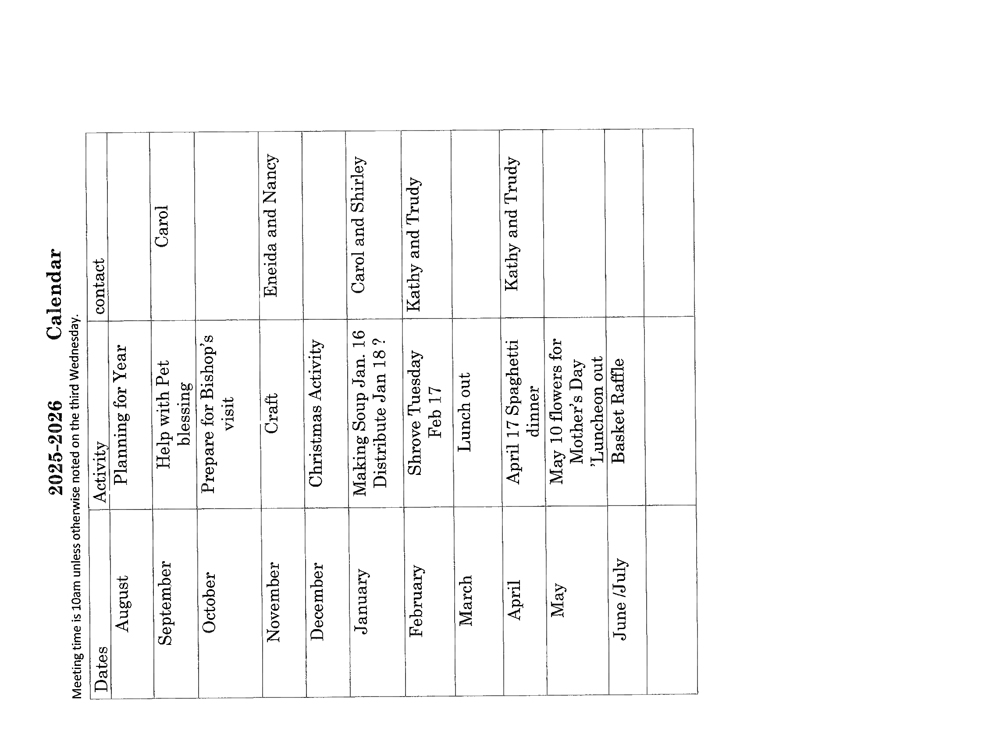

Food Pantry Schedule for October 1, 2025

Picker: Kathy Consiglio

Floater: Trudy Knecht

Runner: Lesley Ciullo
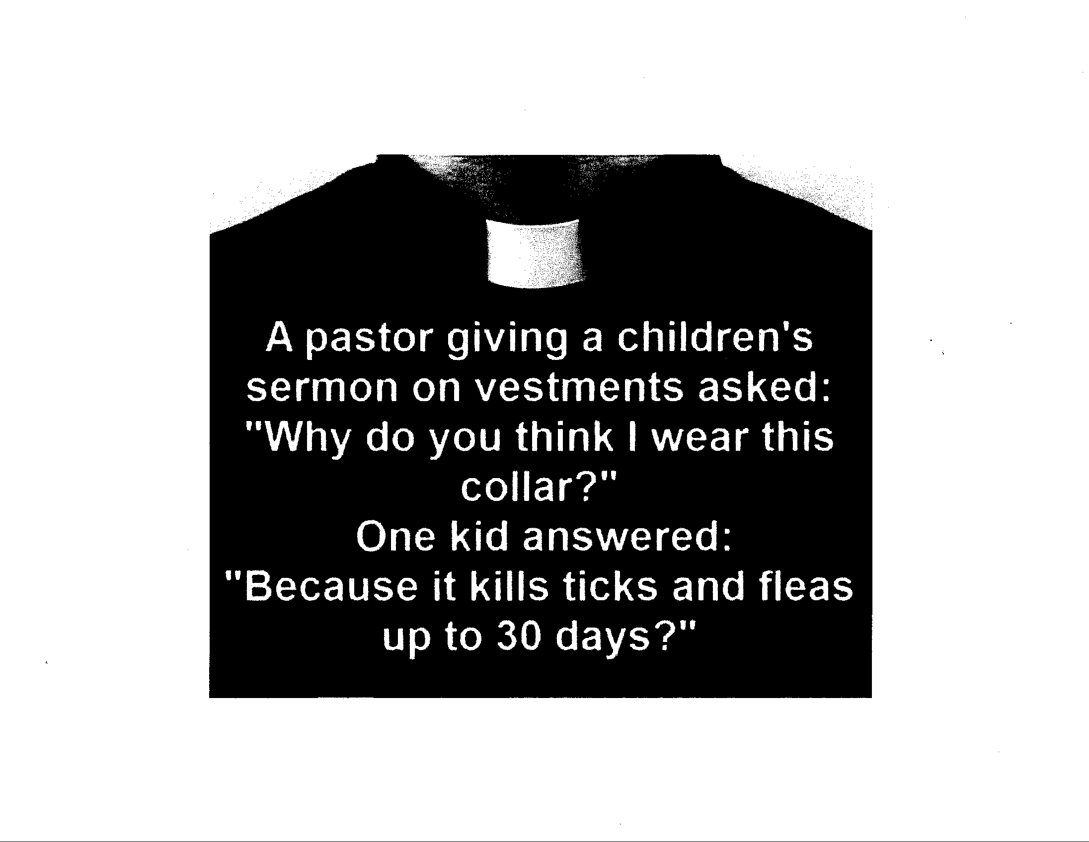



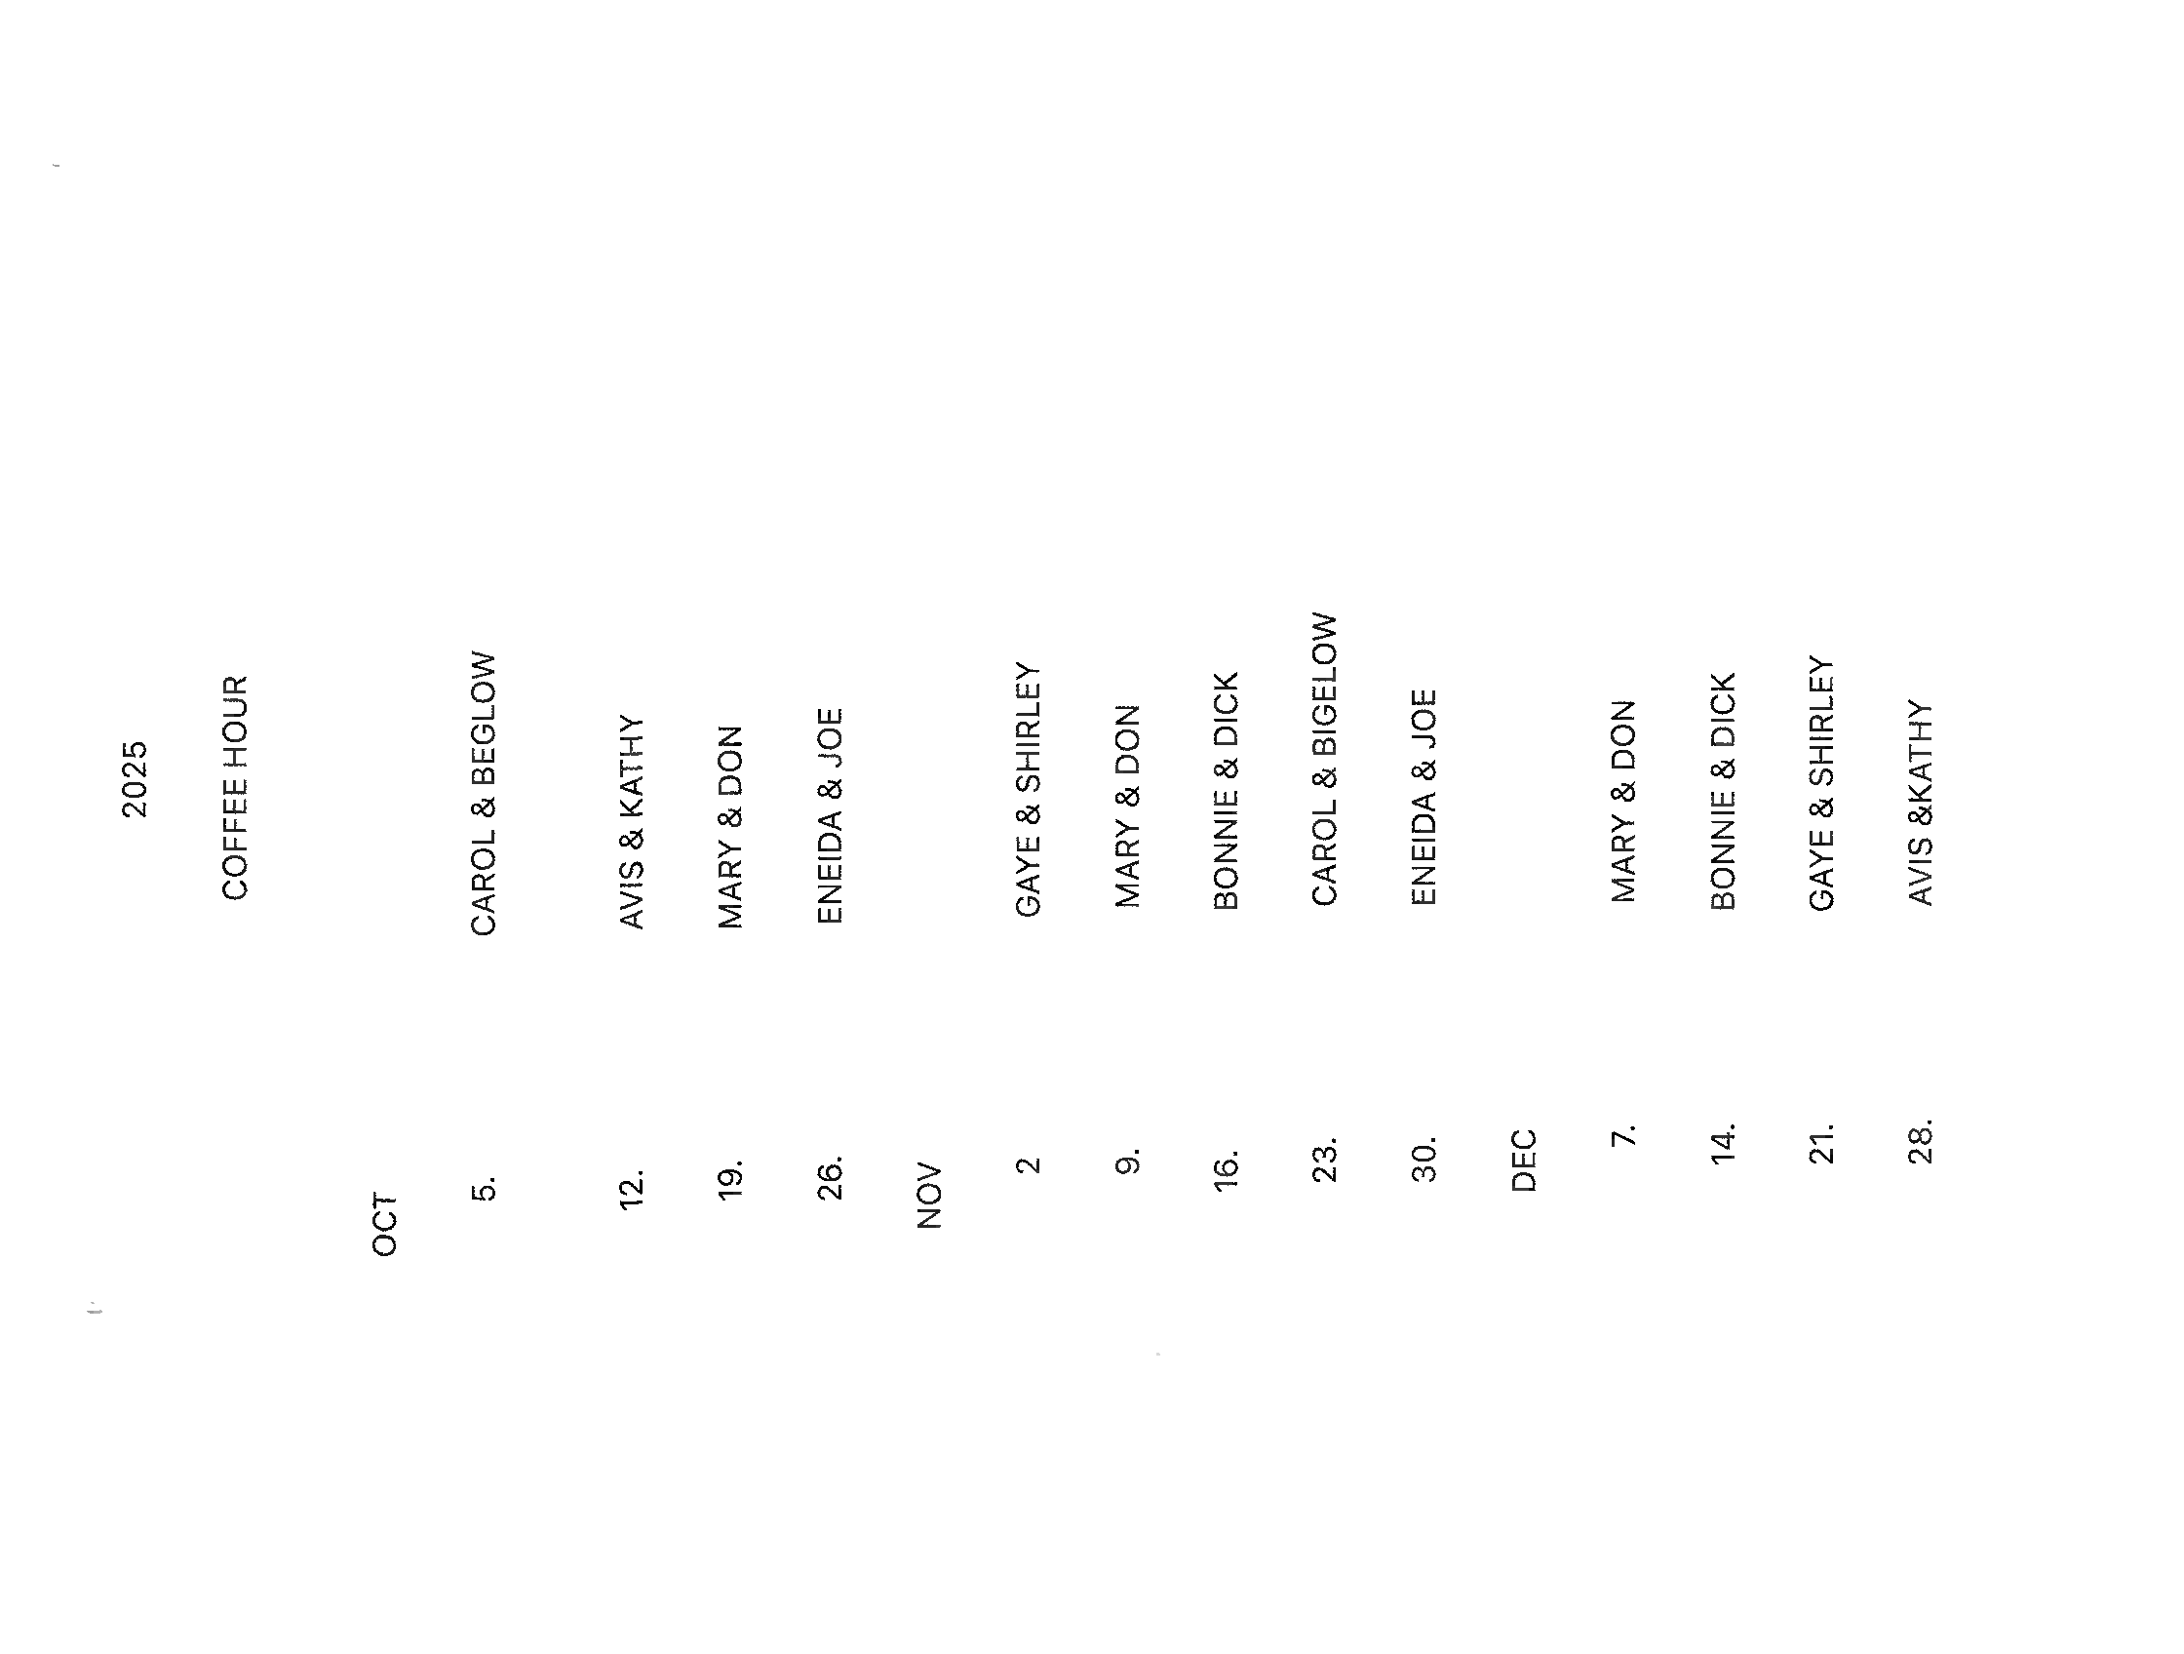

Coffee Hour

Milestones
If your birthday or anniversary is not listed or is incorrect please contact the office and let us know– we want to include you with our blessings and best wishes on your special day.
Birthdays
Russell Peloquin 10/01
Bob Thomas 10/06
Rodger Hutchinson 10/08
Carol Robinson 10/08
Joyce Harris 10/12
Daniels Rupert 10/13
Nancy Comeriato 10/17
Lola Roseberry 10/19
Annette Walker 10/19

Anniversaries

Robert & Jane Tegeder 10/03
Art & Irma McNeal 10/19
Abraham & Nancy Rodriquez 10/25
________________________________________________________________________

If anyone is interested in the Psalm 121 Ministry (Pray Warrior’s) please speak to or call Bebe Hahne at (352) 401-0232

The Church is in need of Acolytes, Altar Guild helpers and Ushers. If anyone would like to volunteer or be a substitute please give Liz Herrick a call for Acolyte at (352) 291-4878 or e-mail her at tinlizziehr@yahoo.com, For Altar Guild, please call Kathy Consiglio at (989) 255-6515 or e-mail her at ktgjjd6@gmail.com, Dick & Bonnie Purnell for Ushers. Call the Bonnie @ (386) 559-2491 Purnell.bonnie@gmail.com or Dick @ (727)992-2397 Purnell.rt@gmail.com

Upcoming Events

October 1, 2025 – Wednesday, Food Pantry at 9:00 – Noon at the Advent

October 5, 2025 – Sunday, United Thanks Offering

October 4, 2025 – Saturday, Daughters of the King (DOK) meet at 10:30am at the Advent

October 14, 2025 – Tuesday, Vestry Meeting at 5:30pm

October 11, 2025 – Altar Guild Meeting at 10:30am

October 11, 2025 – Bob Evans Breakfast Fellowship at 8:00am – All are welcome

October 15, 2025 – Episcopal Church Women (ECW) meet at 10:00am

October 18, 2025 – Clean-up Day at 8:00am – all are welcome

Corrections

If you see that an error was made, please let me know, so that I have the right info.
Thank you, Lesley Ciullo



The Advent Chronicle
Episcopal Church of the Advent
11251 SW Highway 484
Dunnellon FL 34432-6413

