THE ADVENT CHRONICLE


Our Purpose: Love God, Love One Another, Make Disciples
11251 SW Hwy 484
Dunnellon, FL 34432
(352) 465-7272

Office Hours
Mon., Wed., Thurs., 8:30am – 12:30pm
Tuesday 8:30am – 4:00pm
May 2025
episcopalchurchadvent@aol.com

CONTENTS

Message from Fr Barrett ∙ ∙ ∙ ∙ ∙1
Food Pantry Schedule ∙ ∙ ∙ ∙ ∙ ∙ ∙2
Meet Edwin & Maribel Torres Pastors∙ ∙ ∙ ∙ ∙ ∙ ∙ ∙ ∙ ∙ ∙ ∙ ∙ ∙ ∙ ∙ ∙ 3
ECW Spaghetti Dinner∙ ∙ ∙ ∙ ∙ ∙ ∙5
Episcopal Church Women∙ ∙ ∙ ∙ ∙6
Milestones ∙ ∙ ∙ ∙ ∙ ∙ ∙ ∙ ∙ ∙ ∙ ∙ ∙ ∙ ∙6
Up Coming Events ∙ ∙ ∙ ∙ ∙ ∙ ∙ ∙ ∙ 7

Weekly Events
Sunday 9am Services
First Sunday of the month is a Healing Segment

Tuesday: 2ndTues. Vestry Meet at 5:00pm

Wednesday: First Wednesday of the Month is Food Pantry 9am - Noon
3rd ECW Meet at 10:00am

Friday: 12pm Stations of the Cross Only in Lent

Saturday:
1st Saturday of the Month DOK Meet at 10:30am

8:00amBob Evans Fellowship on the 2nd Saturday of the month – All are welcome

Clean-up 8:00am on the 3rd Saturday of the month

A message from Fr. Barrett

The Lord be with you!

We are about to begin an exciting new ministry! For some time our diocese has been aware of the growing Hispanic presence in Central Florida. As a result the diocese added a bilingual member to the staff and set as a goal the creation of at least one congregation per year offering worship in Spanish. A number of churches in our area, including Episcopalian, now offer this ministry. A few months ago Pastor Edwin Torres contacted me. He represents the Assemblies of God tradition. He wanted to plant a worship community in this area reaching out to Spanish speaking Christians. His goal was to host a Bible Study on Thursday evenings and worship on Sunday evenings. He would be starting from scratch with no existing congregation. He asked me if we would help him in his mission.

It has always been my personal dream to offer bilingual worship, but I do not speak Spanish. This struck me as the Holy Spirit once again calling us to mission as with the Food Pantry.

I believe the priority for evangelism is spreading the gospel through quality worship and mission to our neighbors. This should result in a gain in membership, but remember that Christ calls us to a primary goal of spreading the gospel and serving our neighbor. Anything else that results is a benefit but not the primary goal. If we are faithful, I believe God will provide.

I brought this proposal to the Vestry and they approved it. I then drew up a contract which the Vestry also approved. Pastor Torres signed the contract prior to receiving a key. This contract is included in the newsletter this month.

You will see some evidence of our new guest. They will display events on the left side of the narthex as you face the altar. They will have signage on the outside of the church below and not blocking our signs. We have also agreed to give them a modest amount of area for storage. At some point you may see things like drums in our music area. Don’t worry they have a different worship style but our worship will remain the same!

I hope you will join me in welcoming our neighbors as we continue to be faithful and obedient servants of our Lord who gave us the Great Commission. If you have friends who speak Spanish, tell them about this new ministry. They may even decide to sample both our faith families!

Peace Father Barrett

Food Pantry Schedule
May 7, 2025

Pickers: Gaye Barrett

Runner: Lesley Ciullo


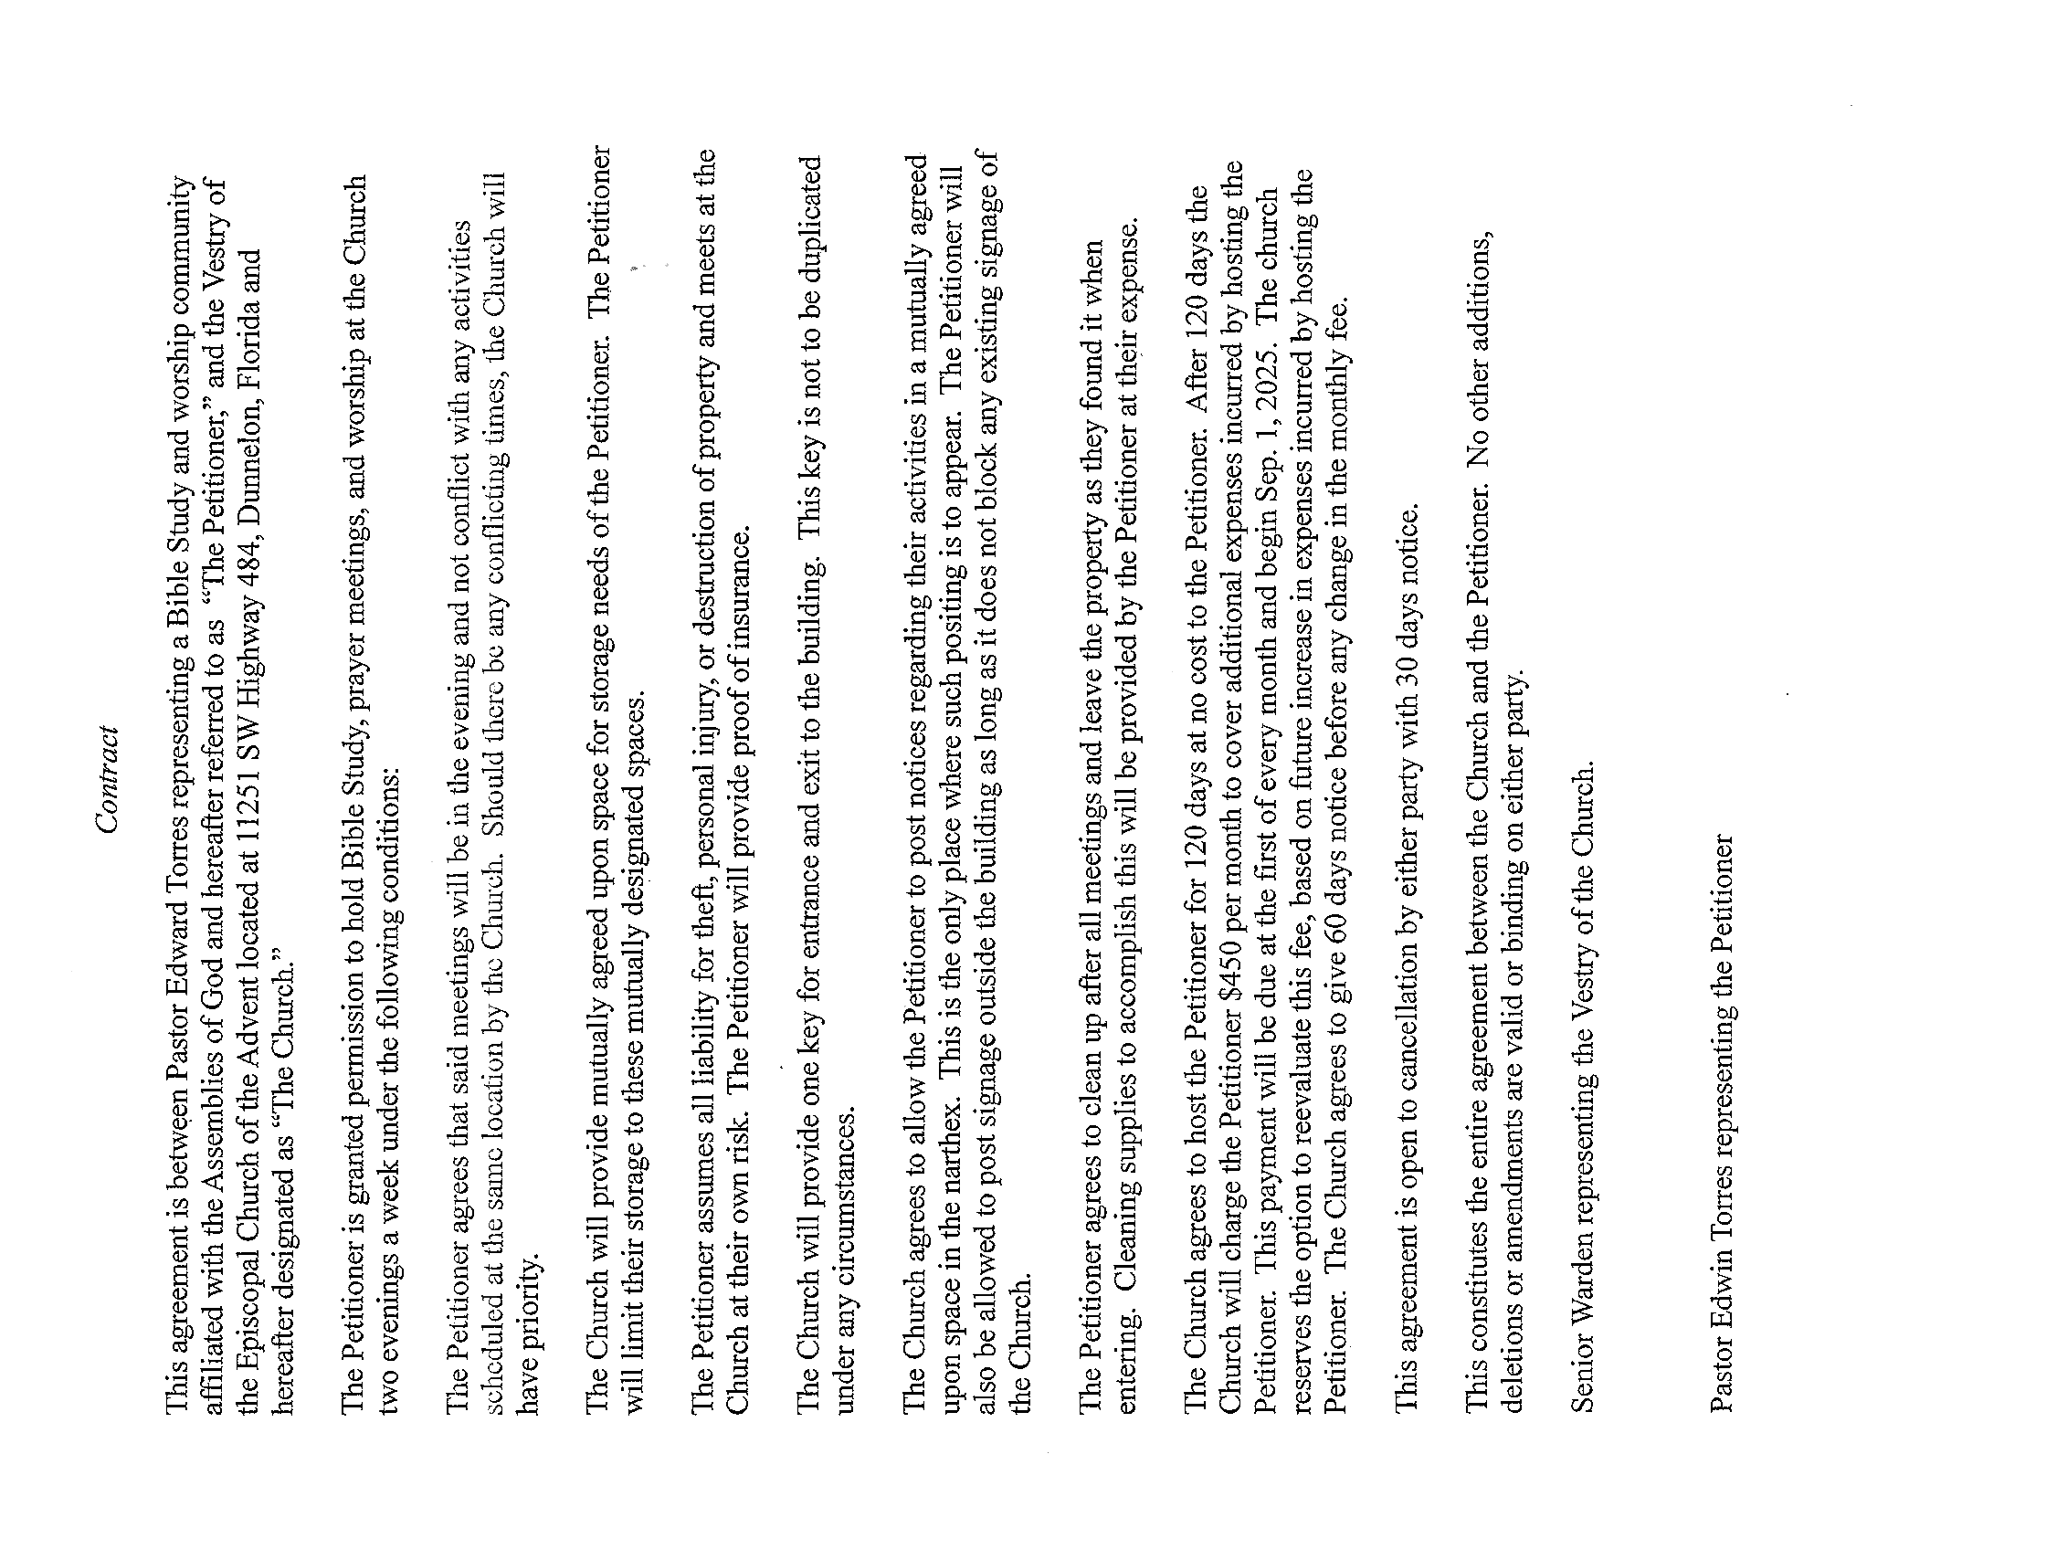




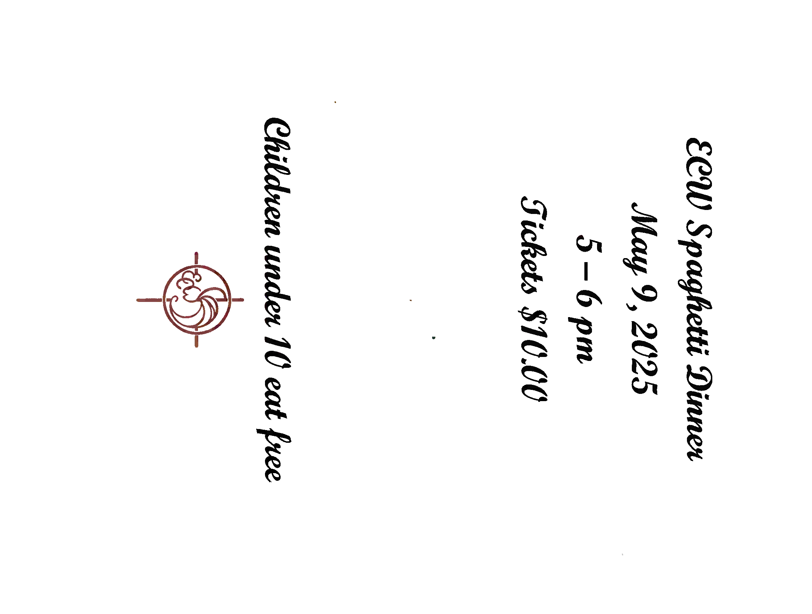


Episcopal Church Women

ECW News
To show our support for the fire house across the road from the church, we are asking people to donate baked goods once a month to them. We will have a chart to sign up on. We were thinking about 2 people per month with the baked goods to be delivered on the 3rd Sunday of each month. We felt people would be coming to church and not have to make a special trip to the fire house.

We also wanted to remind everyone about the Spaghetti dinner on May 9 at 5pm. Tickets are available from Shirley Peloquin and Leslie in the office for $10. Children under 10 eat free.

A parish potluck dinner is planned for May 21, 2025. Please plan on attending and please bring a friend.

Also, a reminder to create a basket for our basket raffle in June. All are welcome.

The Province IV Retreat is June 2-4 at Camp McDonald in Alabama. If interested in attending please see Liz Herrick.

Milestones
If your birthday or anniversary is not listed or is incorrect please contact the office and let us know– we want to include you with our blessings and best wishes on your special day.
BIRTHDAYS

Jeanne Dooley 05/15
Rachael Spanjer 05/17
Shirley Thomas 05/19
Gordon Herrick 05/21
Ronald Purnell 05/22

Anniversaries

Bruce & Missy Monforte 05/02
Ronald & Lola Roseberry 05/17
Carlton & Avis Nettles 05/23

________________________________________________________________________

The Church is in need of Acolytes, Altar Guild helpers and Ushers. If anyone would like to volunteer or be a substitute please give Liz Herrick a call for Acolyte at (352) 291-4878 or e-mail her at tinlizziehr@yahoo.com, For Altar Guild, please call Kathy Consiglio at (352) 465-7272 or e-mail her at ktgjjd6@gmail.com, Bonnie & Dick Purnell for Ushers. Call Bonnie (386) 559-2491 or E-mail: Purnell.bonnie@gmail.com or Dick at (727) 992-2397 or E-mail: Purnell.rt@gmail.com

Upcoming Events

May 3, 2025 – Daughters of the King Meet at 10:30am

May 7, 2025 – Food Pantry 9am to Noon

May 7, 14, 21, 28, 2025 3:45pm – Choir Practice

May 10, 2025 –Bob Evans Breakfast Fellowship at 8:00am – All are Welcome

May 13, 2025 – Vestry at 5:00pm

May 17, 2025 - Clean-up Day at the Advent at 9:00am

May 21, 2025 – Episcopal Church Women (ECW)

Corrections

If you see that an error was made, please call the office at (352) 465-7272 so that I have the right info.
Thank you, Lesley Ciullo
_____________________________________________________________________

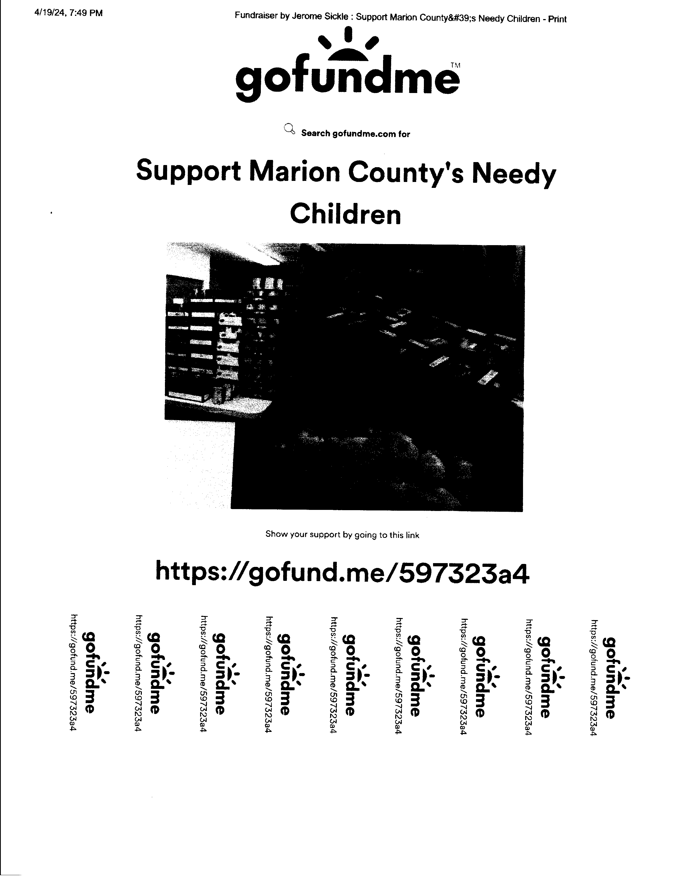

The Advent Chronicle
Episcopal Church of the Advent
11251 SW Highway 484
Dunnellon FL 34432-6413

